To Test the GUI, go the src/gui and run Main.java

**To test the start of the game:**

The initial window should look like this and the “Restart” and “Forfeit” should be disabled:

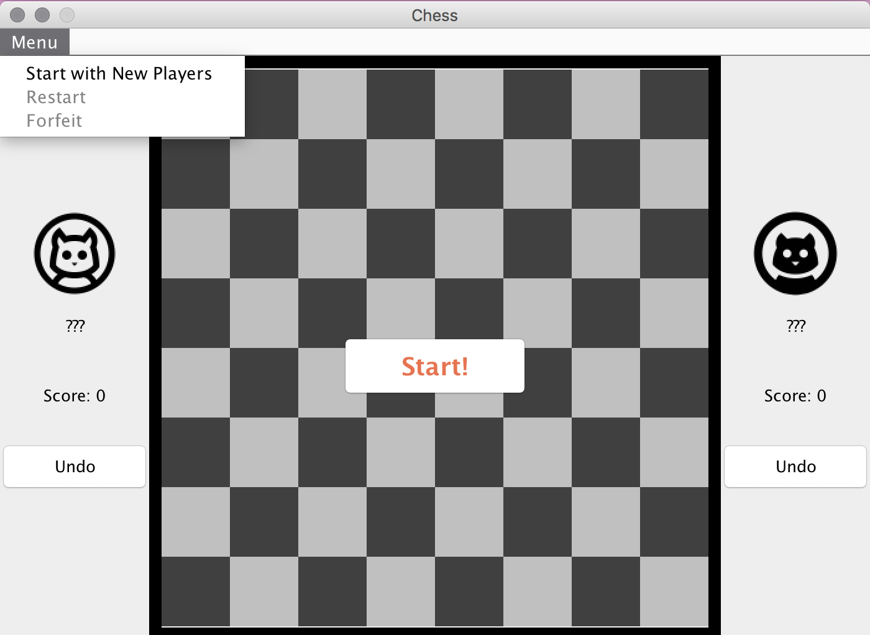

The “Start!” in the middle of the board and the “Start with New Player” in the menu should have the same effect. Click on “Start!” to input names of players and set preferences (whether to play with custom pieces):

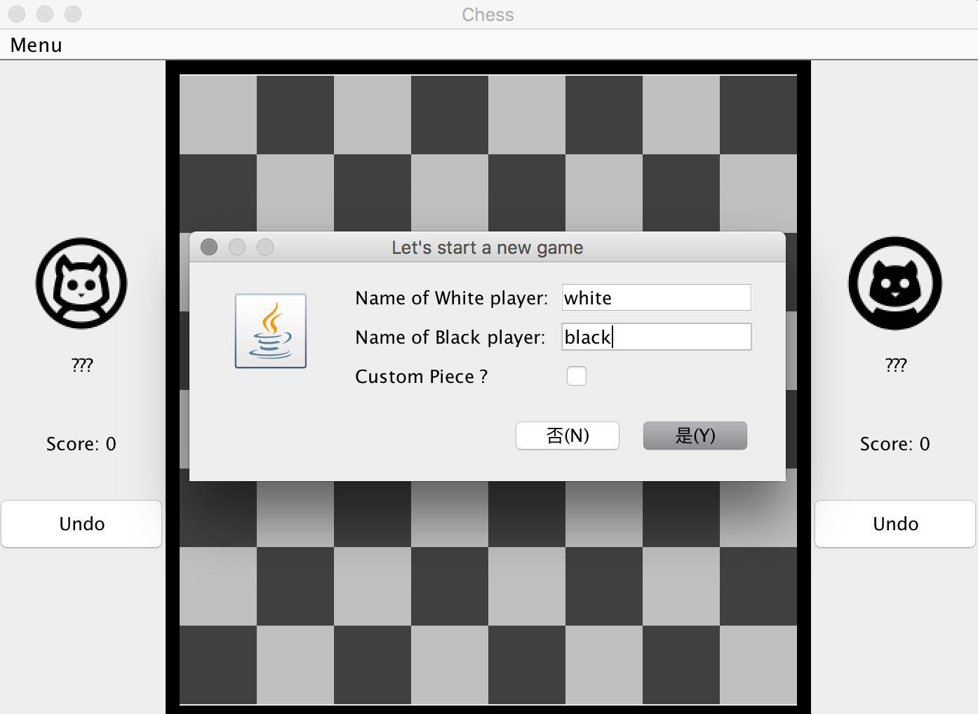

The name of players should be updated after clicking on yes.

The “Restart” and “Forfeit” should be enabled.

The board should look like this with the “Custom piece?” unchecked:

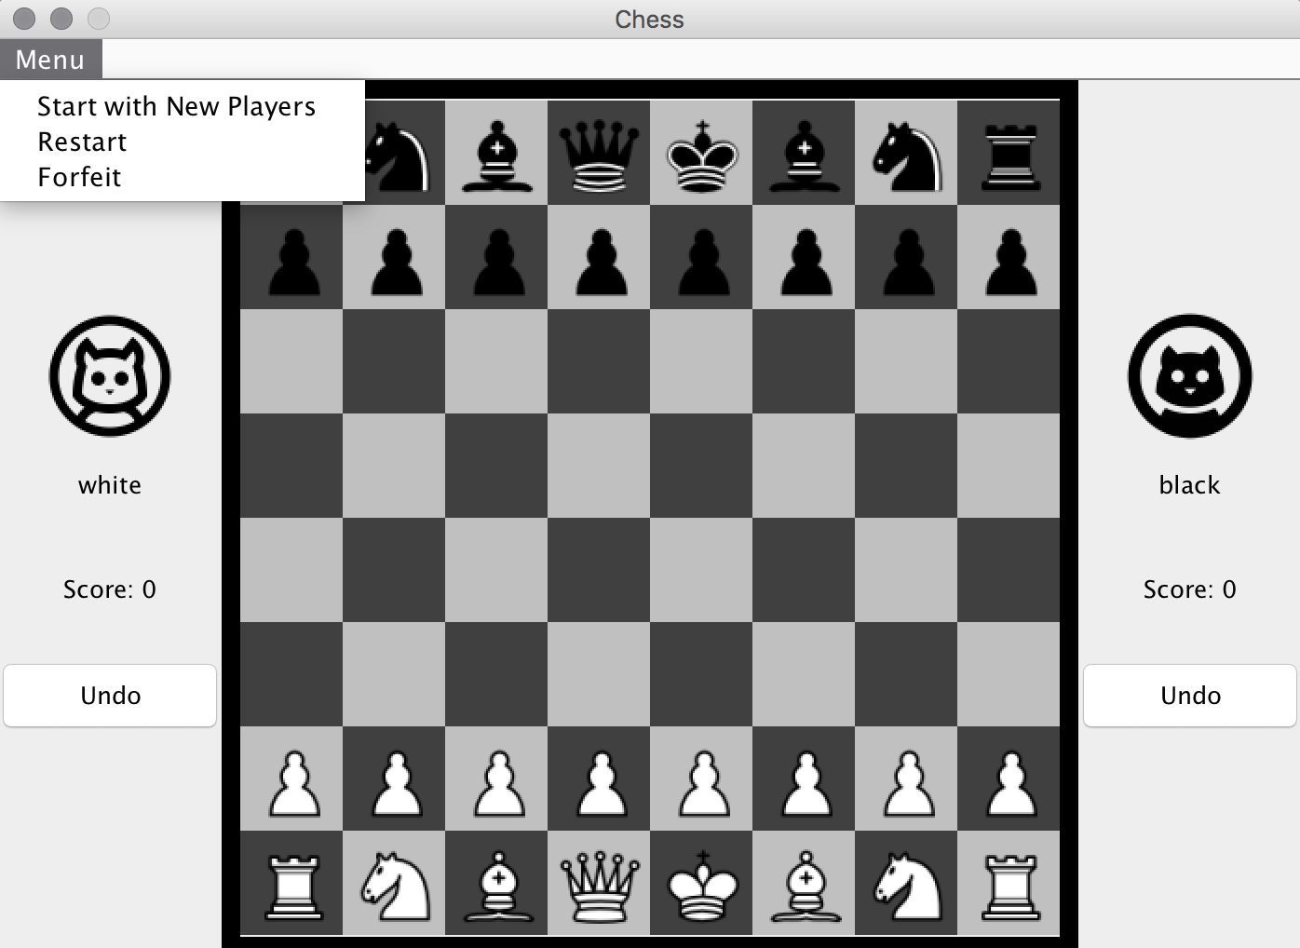

The board should look like this with the “Custom piece?” checked:

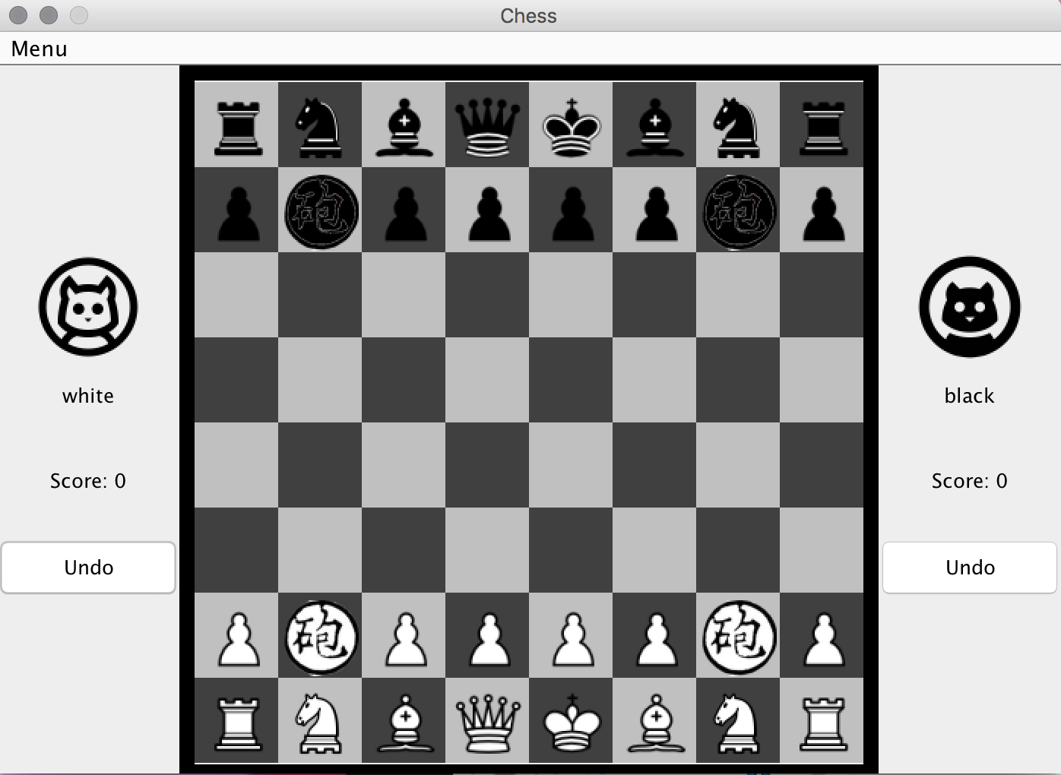

**For the legal moves check:**

Click on one of the pawns, the destinations that can be reached with legal moves should be highlighted:

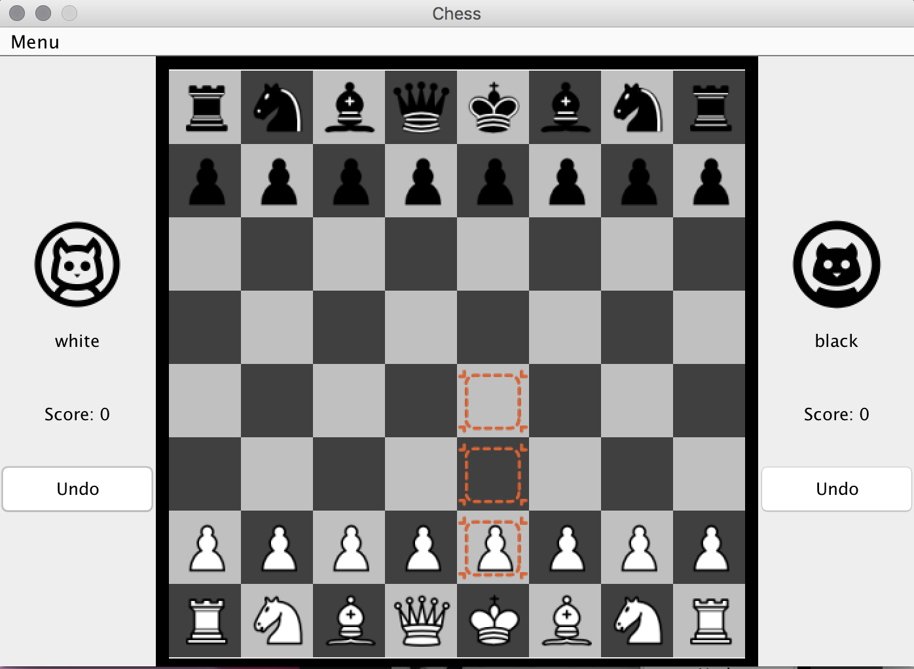

Click on the upper highlighted square to move the piece:

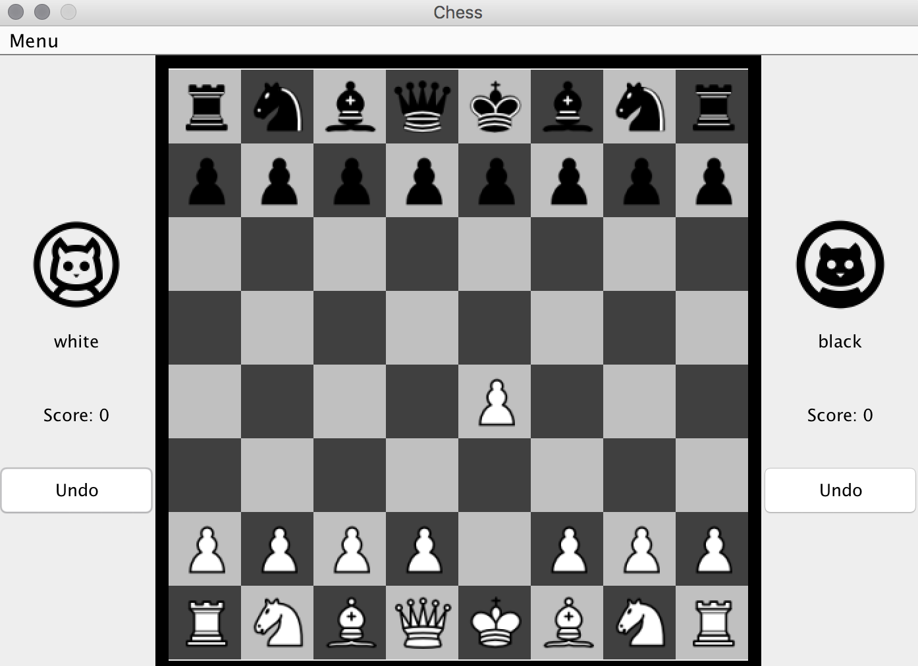

**To test the game loop (taking turn checks):**

Clicking on any white pieces should have no effect.

Click on one of the black pawns get the highlight of legal moves:

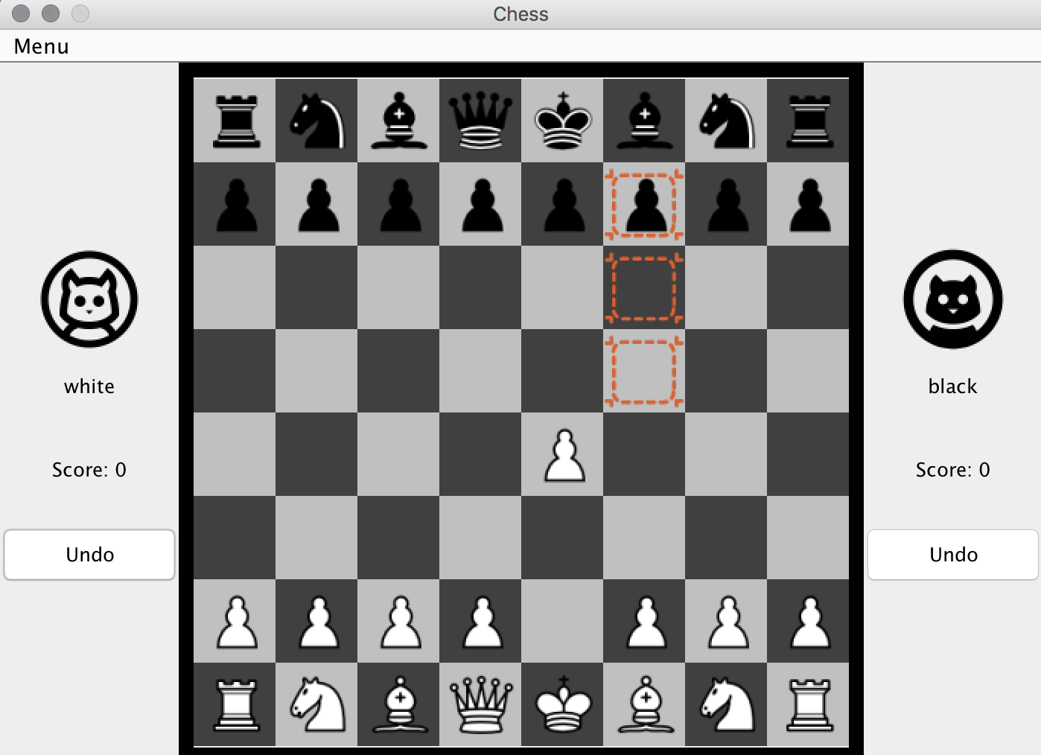

**To test the effect of illegal moves:**

Clicking on any squares that are not highlighted will unhighlight the board: 

But it should still be in black player’s turn as any black pieces can be moved:

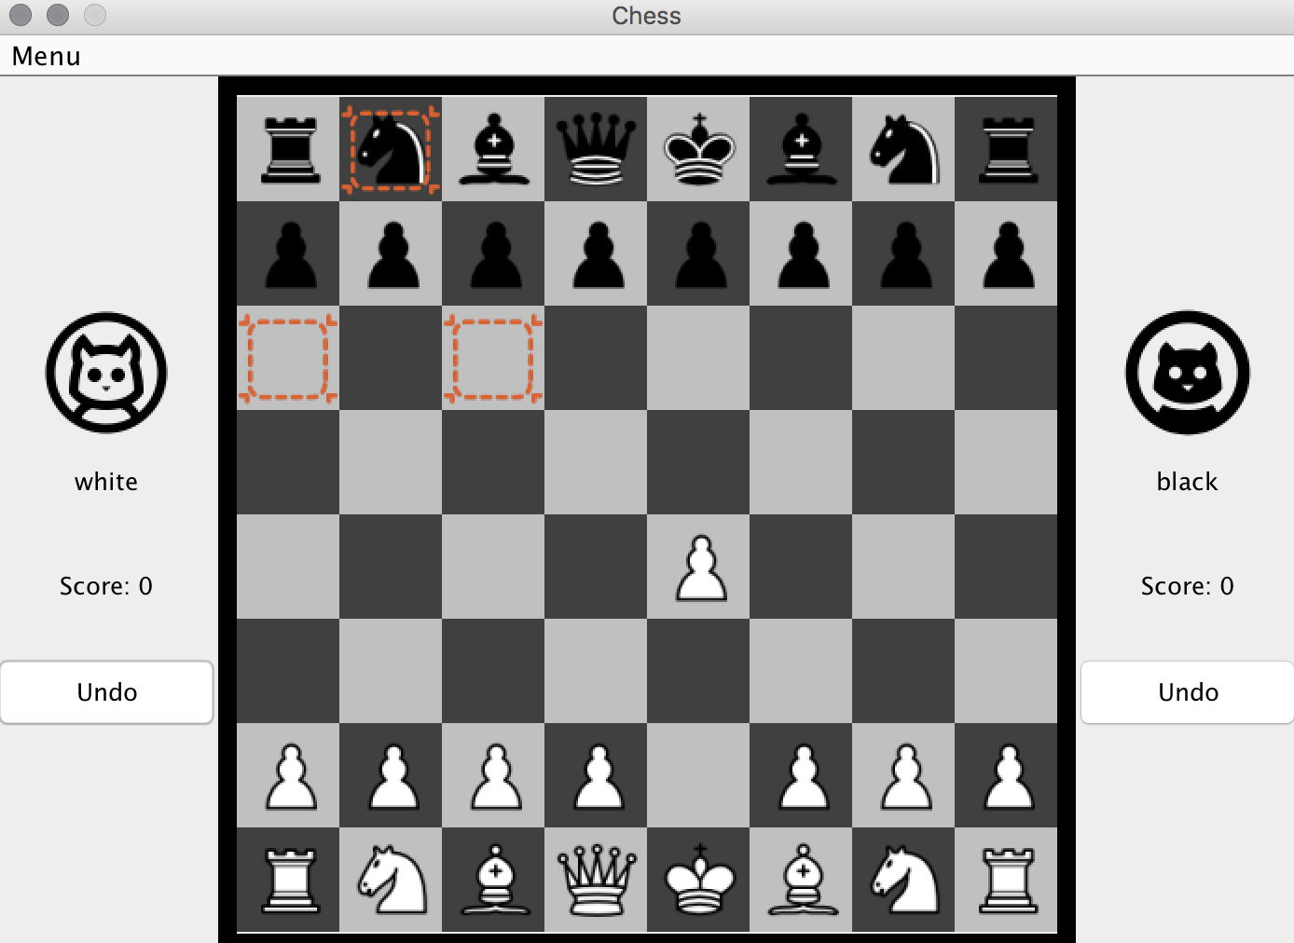

Let’s move the black pawn:

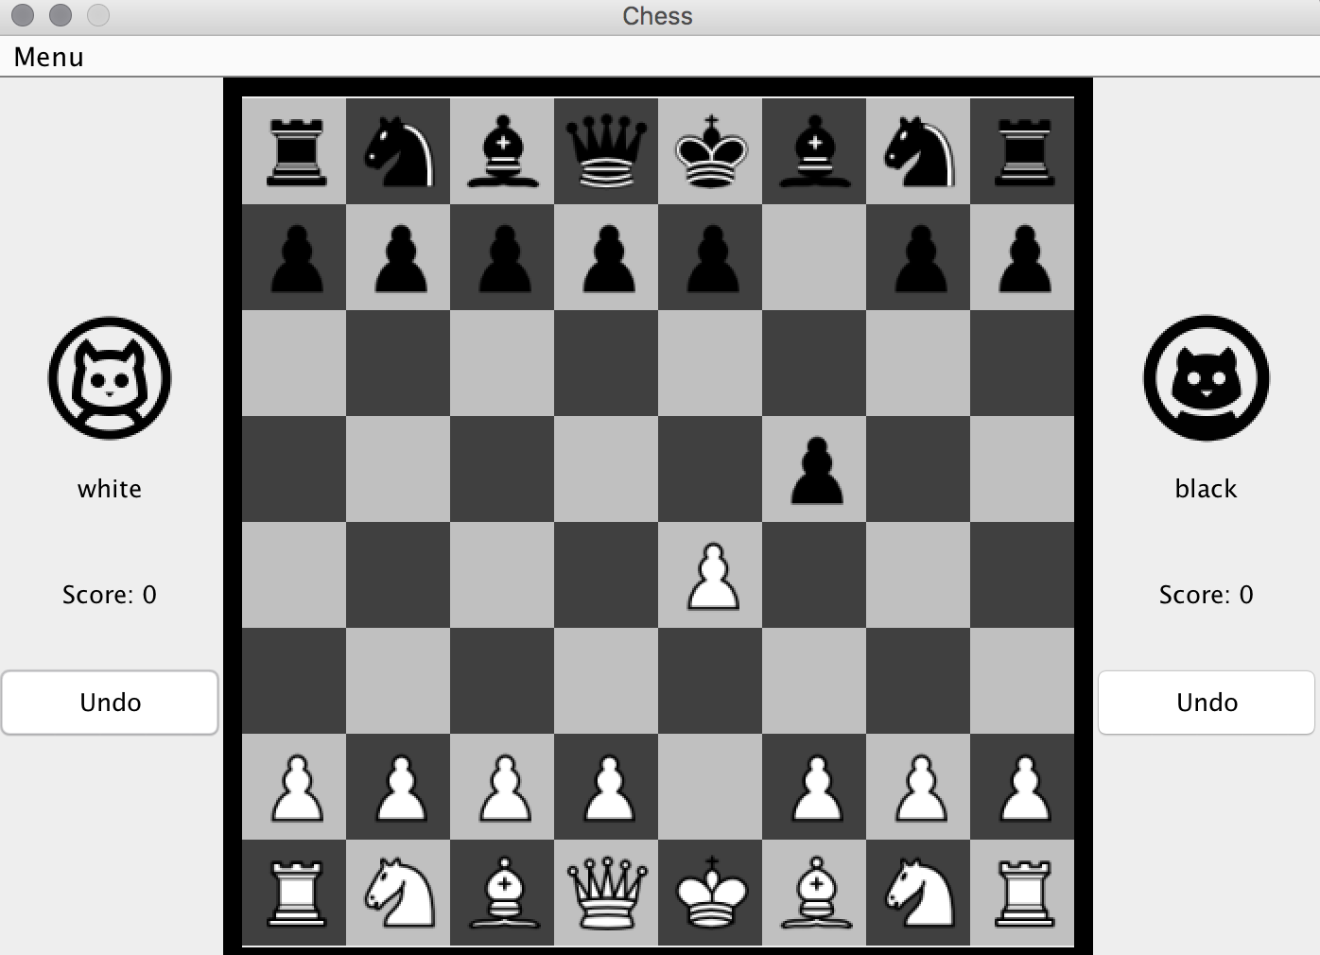

**For capturing test:**

Click on the white pawn we just moved in the previous round, the highlight will show in the square which contains the black pawn:

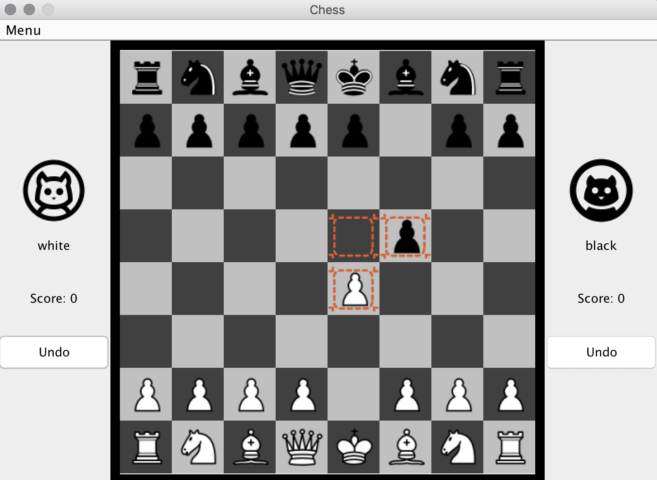

Click on the black pawn and capture it:

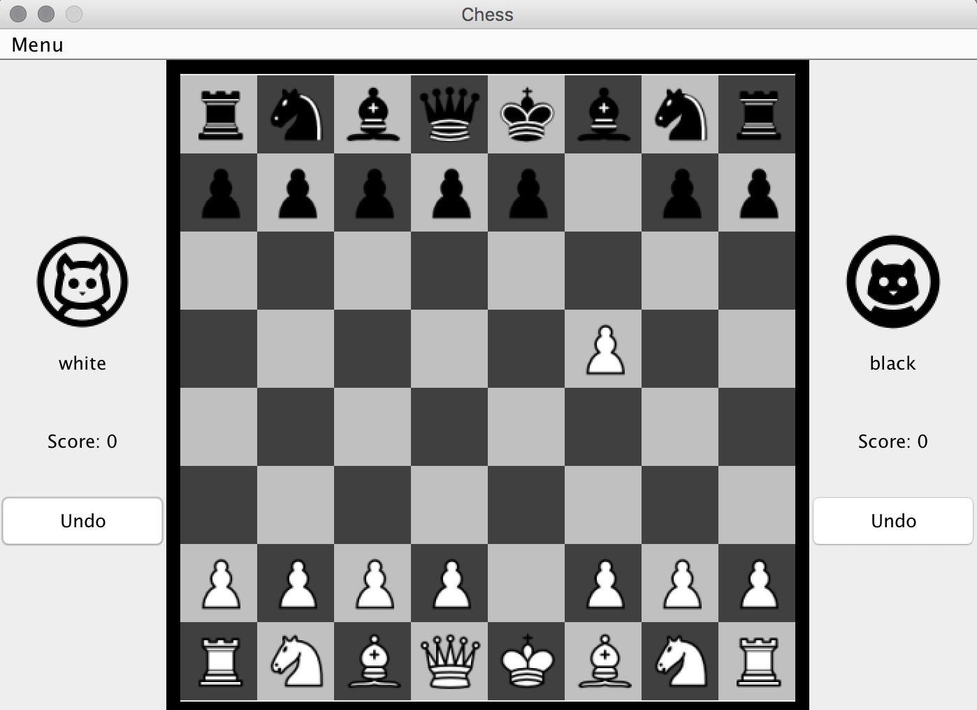

**To test “Undo” buttons:**

Since we just moved a white piece, clicking on the black player’s “Undo” should not work.

Click on the white player’s “Undo” button, the board will be recovered to the state where the black pawn has not been captured:

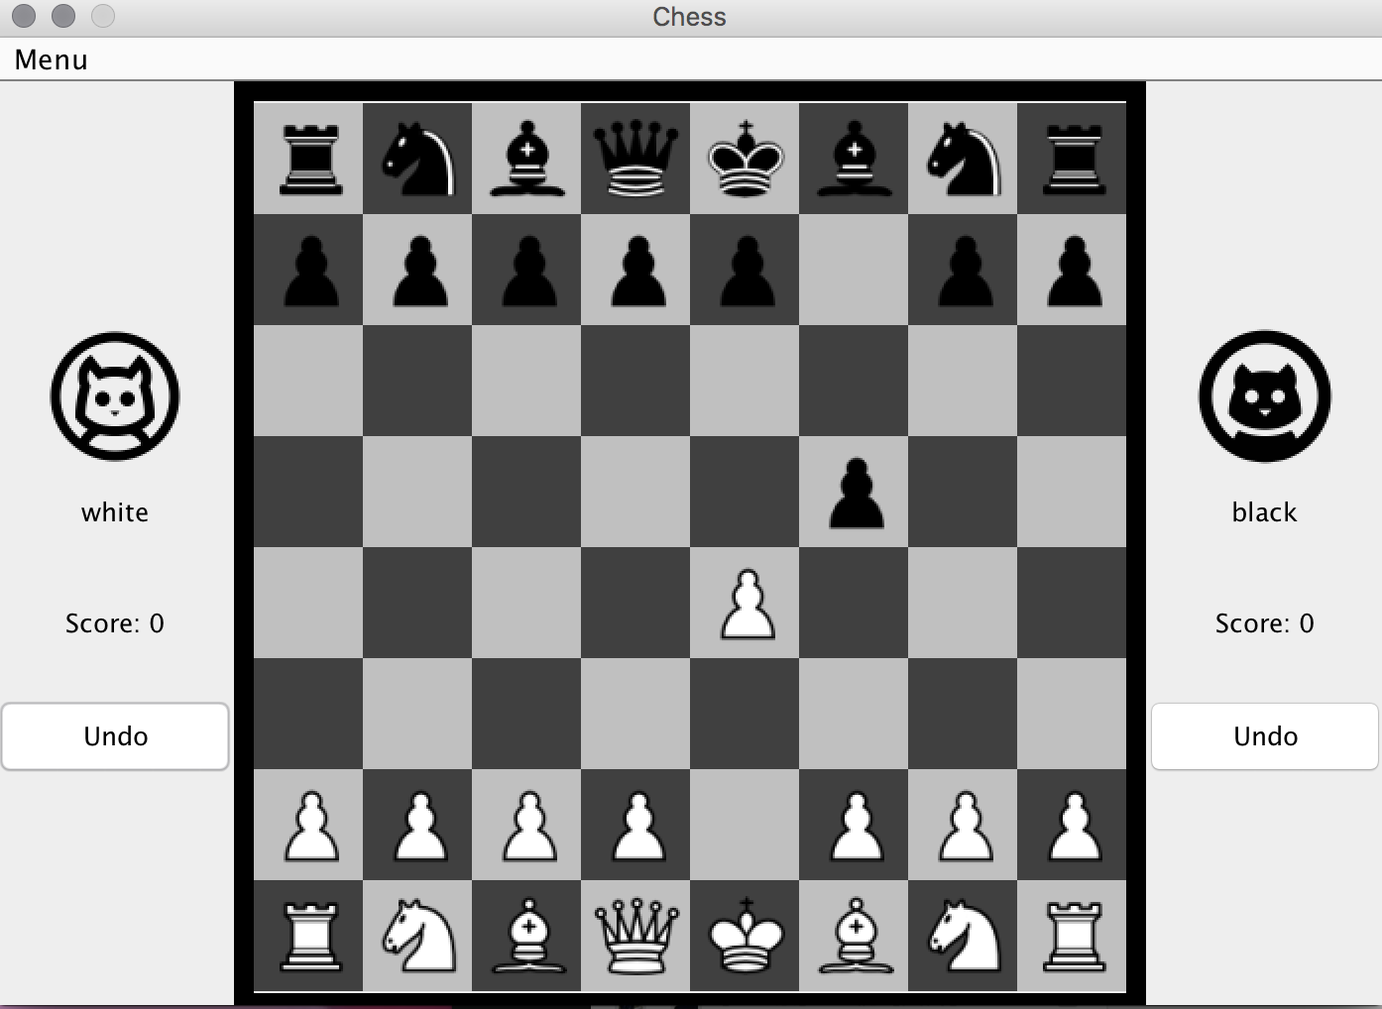

After the undo, it should be the white player’s turn to make a move. Some of the squares should be highlighted by clicking on any white pieces but not black pieces.

**To undo multiple steps:**

Since white player hasn’t make the move, the black player can also undo the last move he did. This time, clicking on the white player’s “Undo” should not work.

Click on the black player’s “Undo” button, the board will be recovered to the state where the black pawn has not been moved:

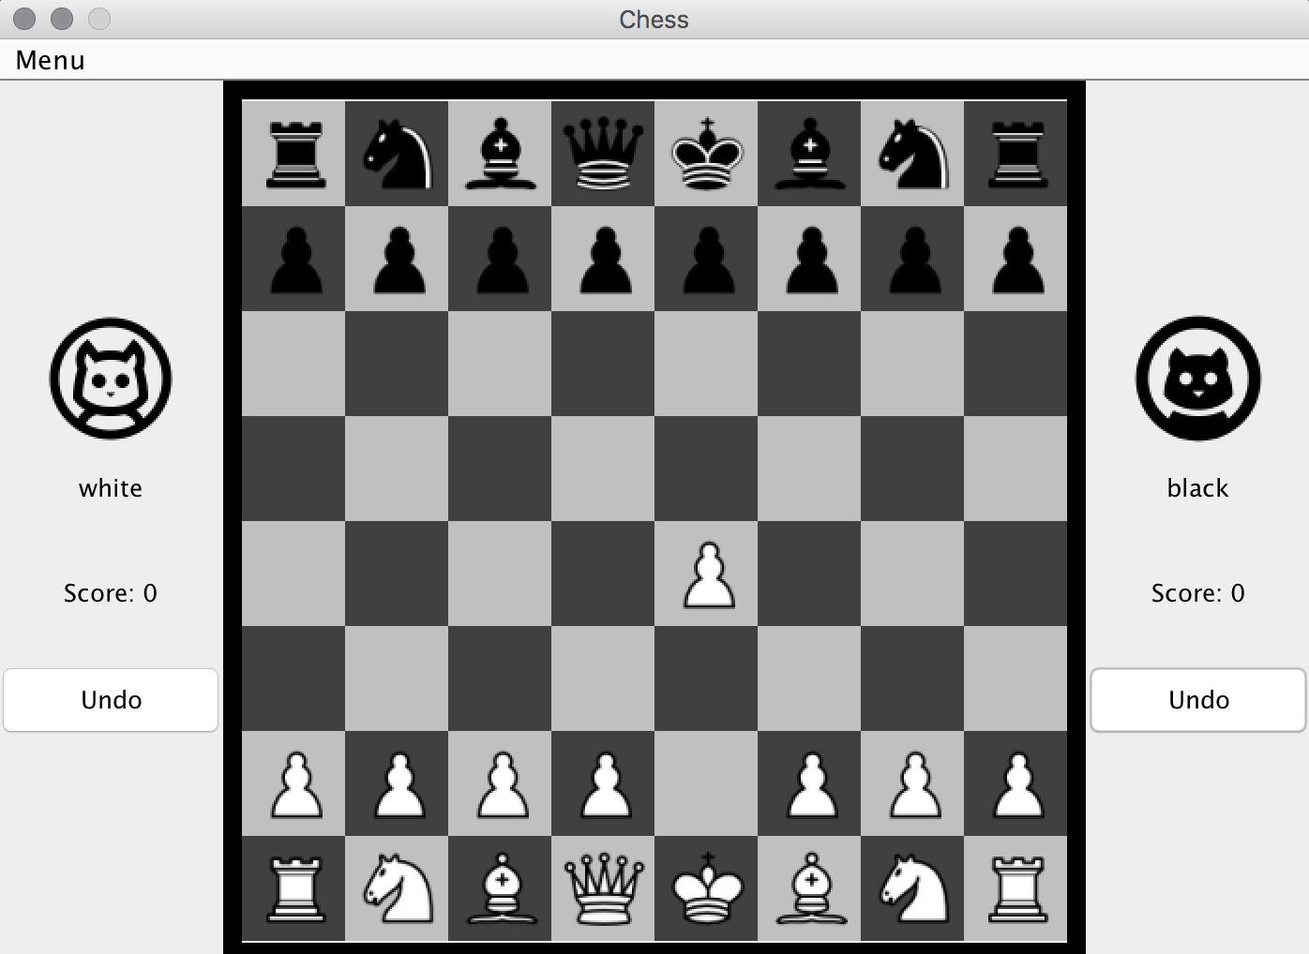

Redo the two moved that we did to get the following board with a black pawn being captured:

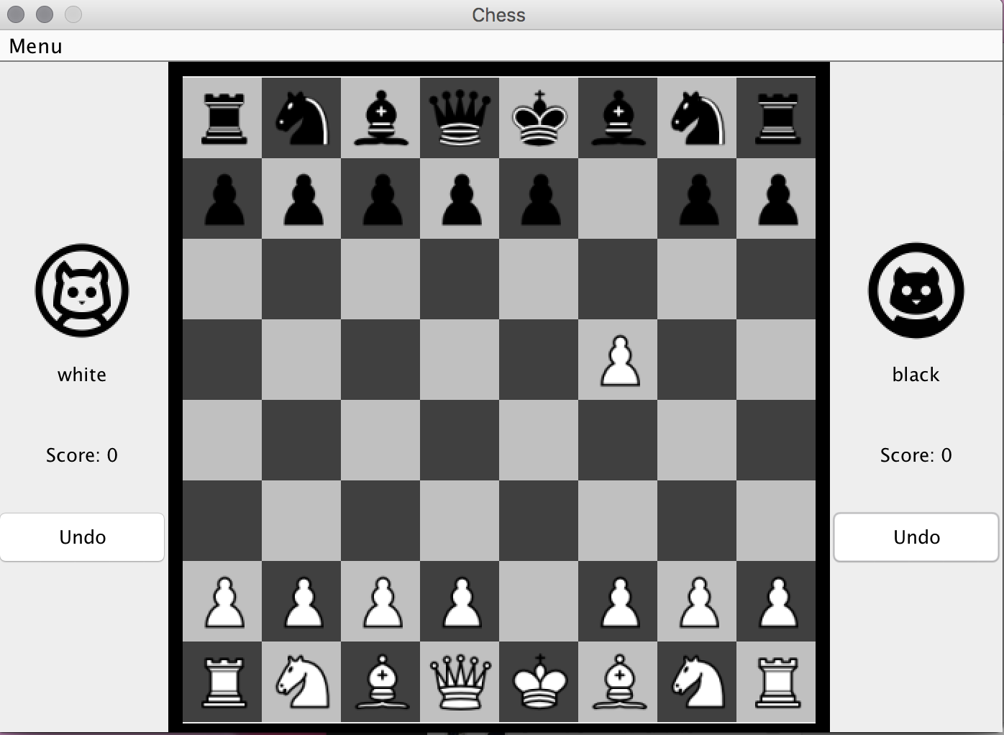

**To test checkmate:**

Move the black pawn:

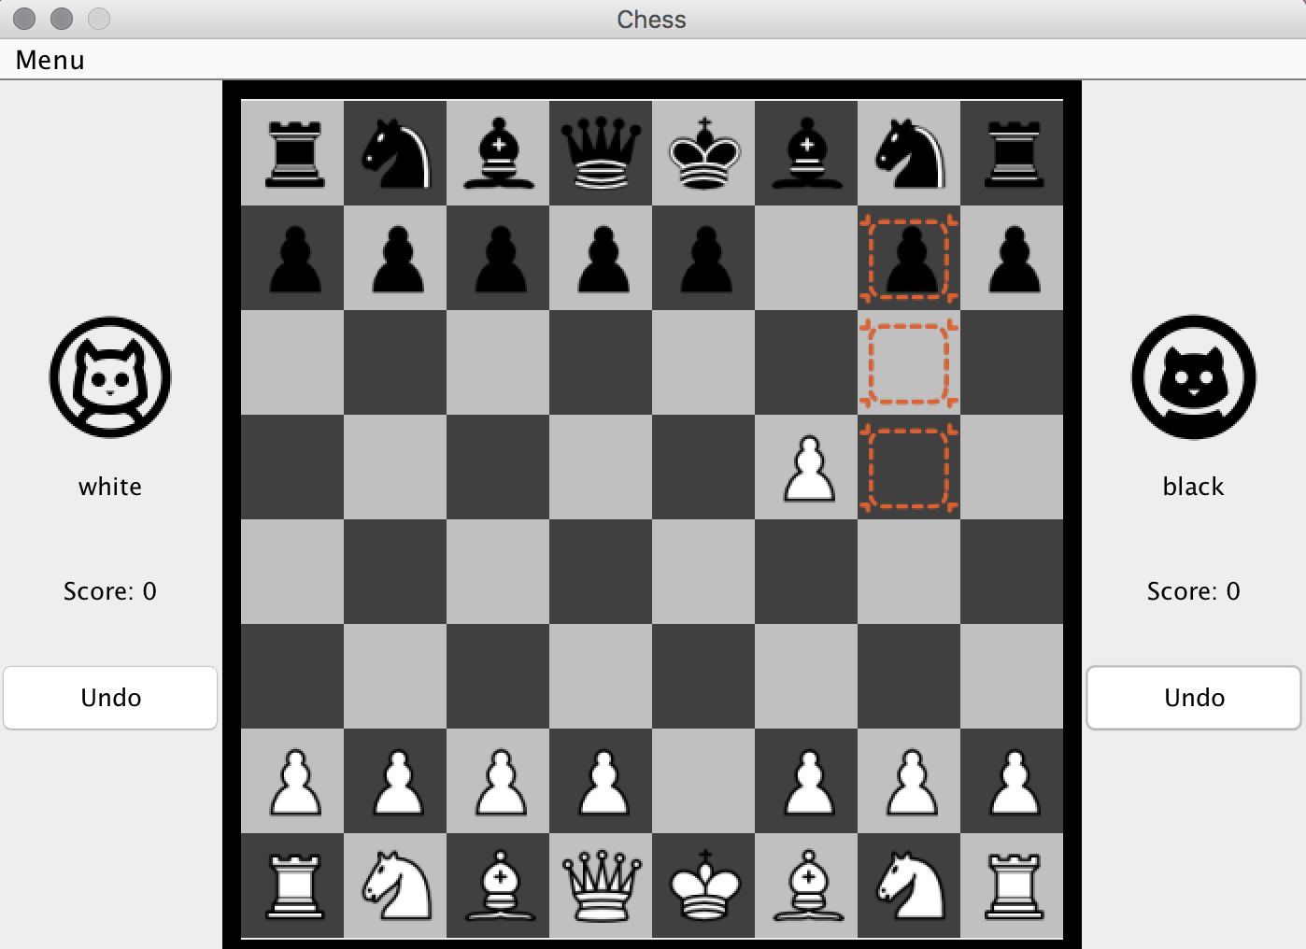

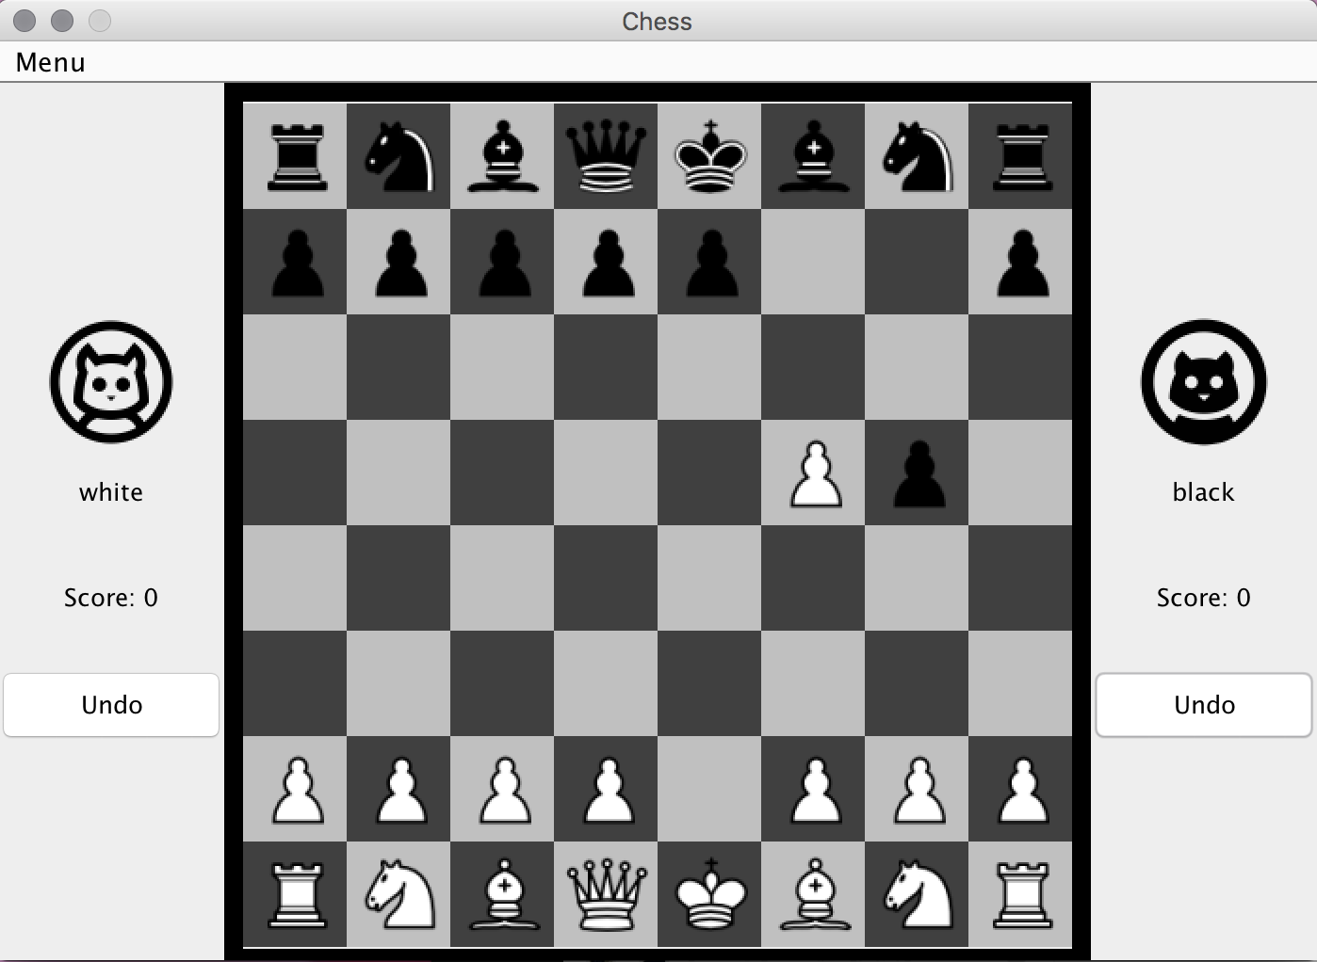

Move the white queen:

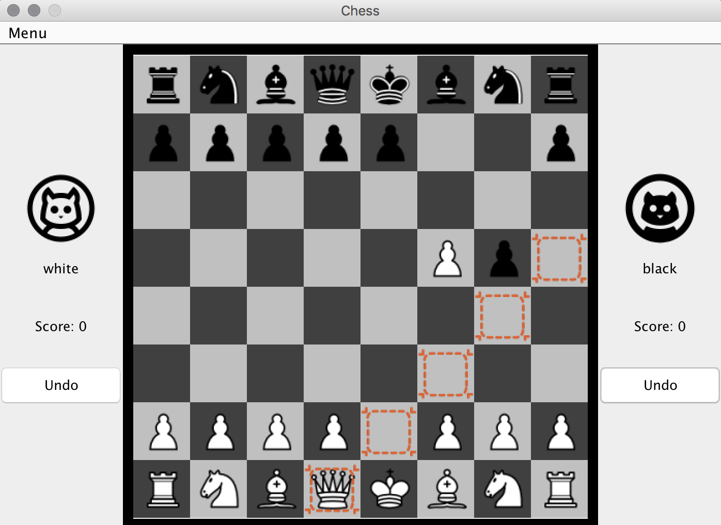

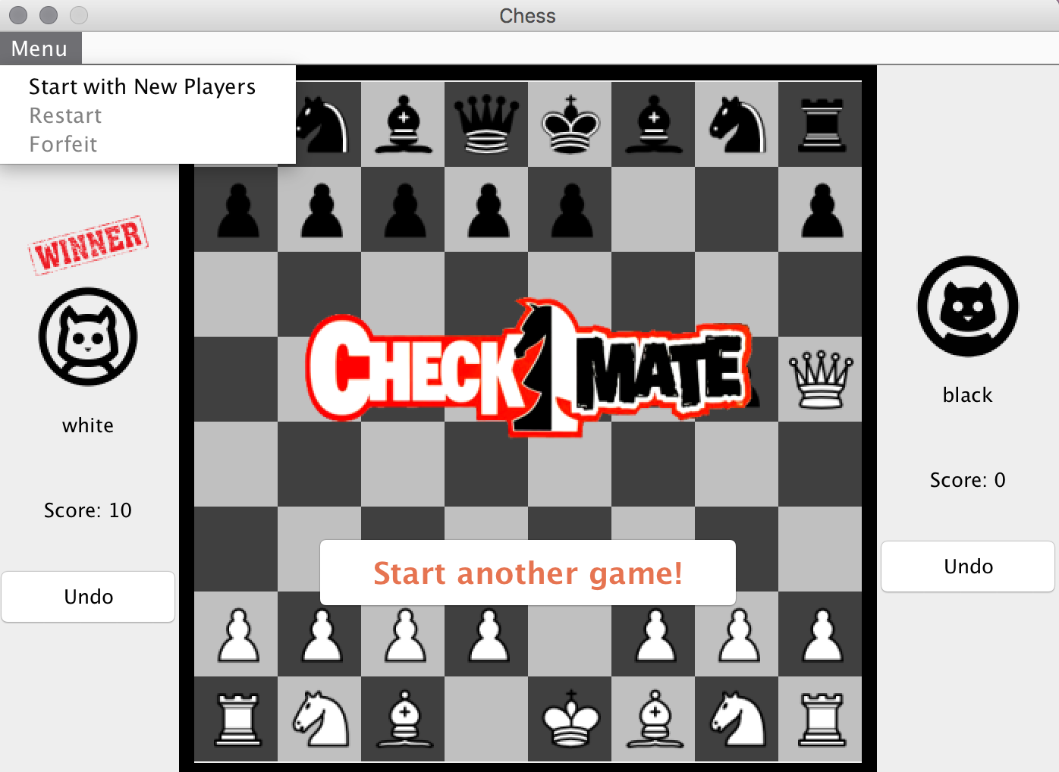

As we can see, checkmate! The black king is in check and cannot escape. The winner is white player. The score is incremented by10. The “Restart” and “Forfeit” are disabled since the game is over.

Now, we have two options. One is to play the game with same players and the score will be recorded. The other is to change players and start the whole game over with scores initialized to 0.

To continue the game:

Click on “Start another game!”:

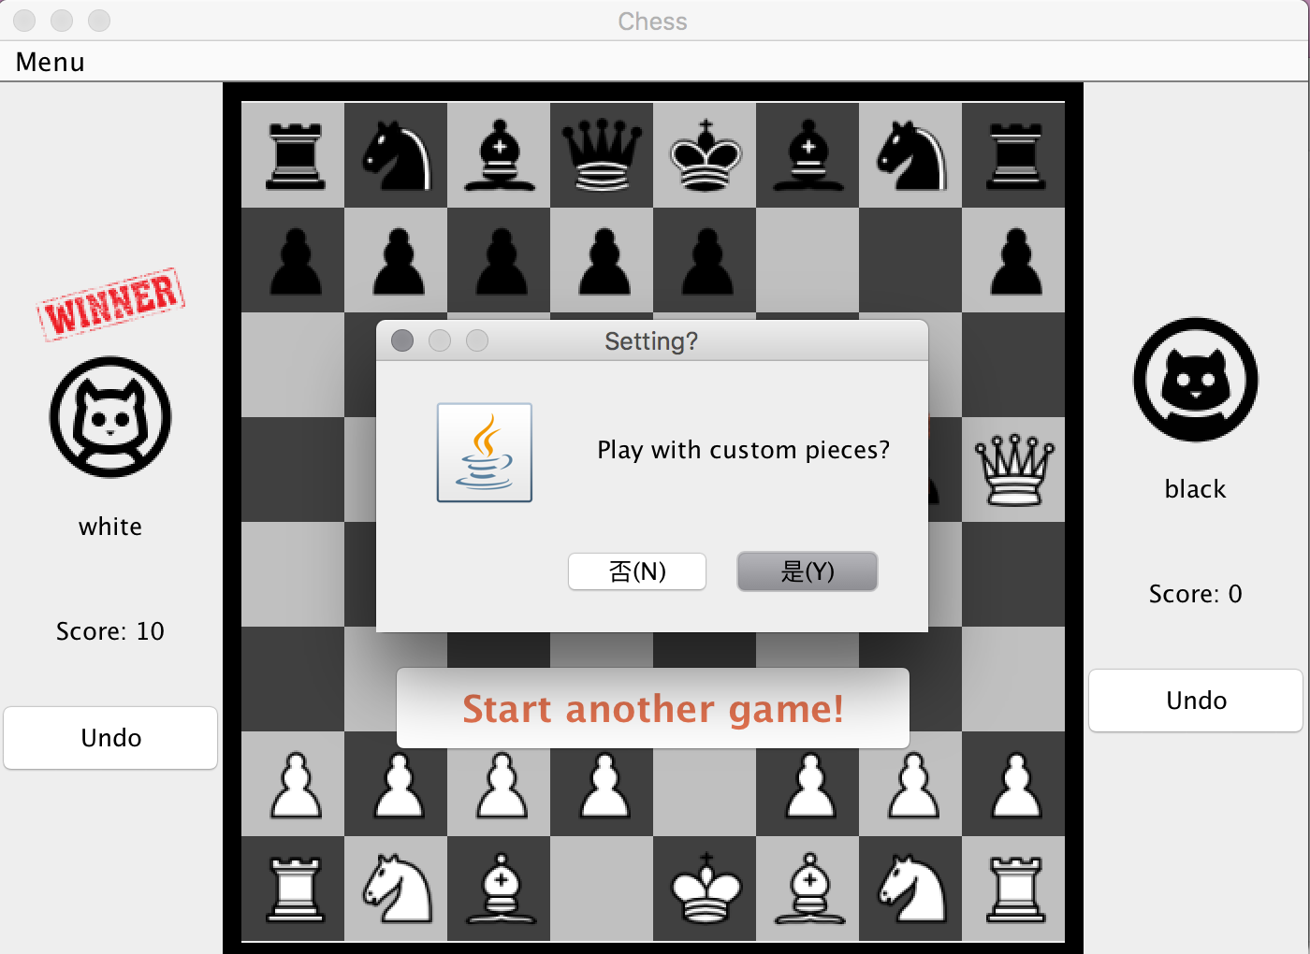

Click on “Yes”, the board with custom pieces will be displayed and the score is recorded:

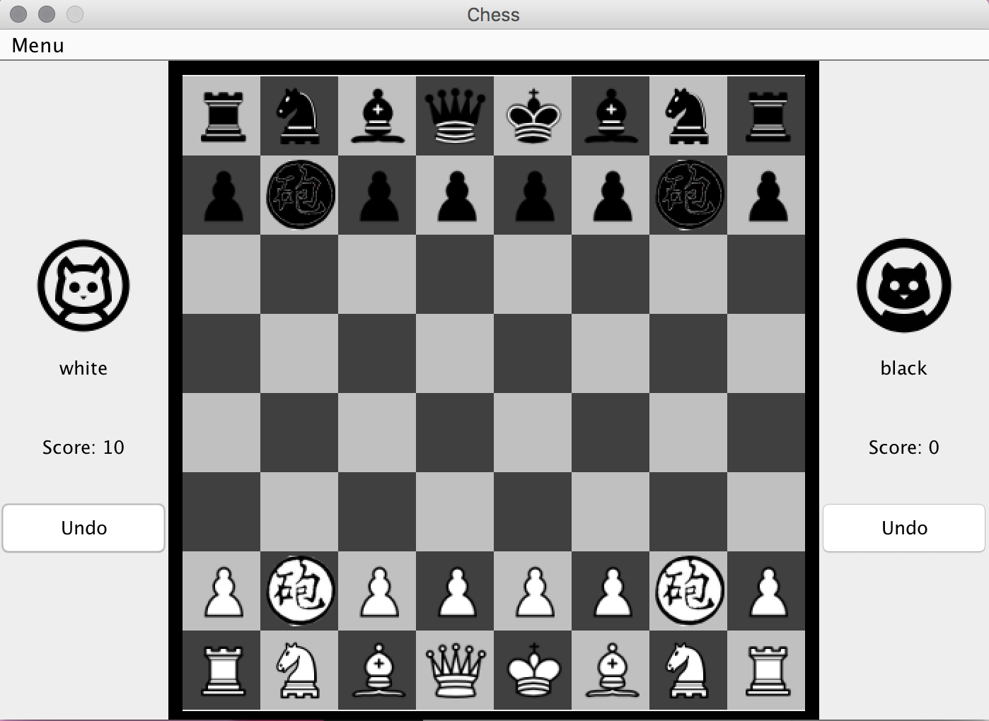

**To test “Restart” in the menu:**

Click on menu and “Restart”, it will ask whether to play with custom pieces:

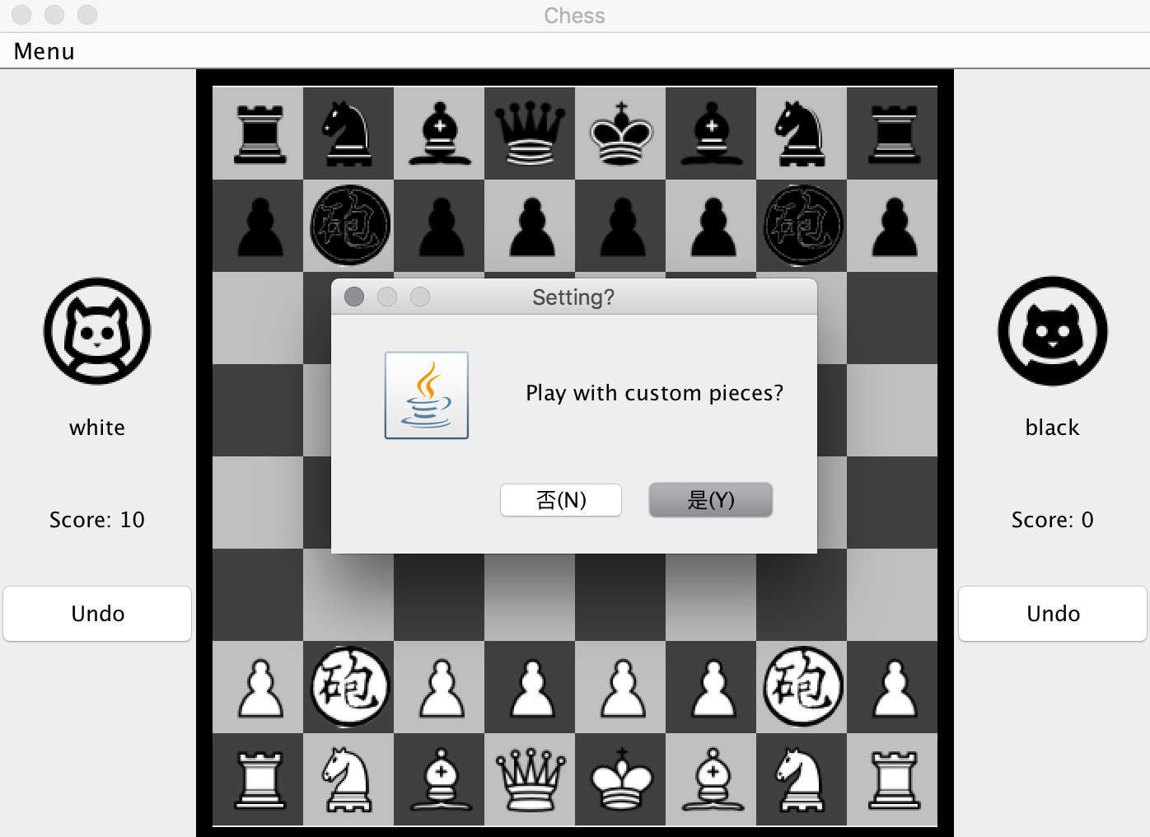

Click on “No”, standard board will be displayed, and score is still recorded:

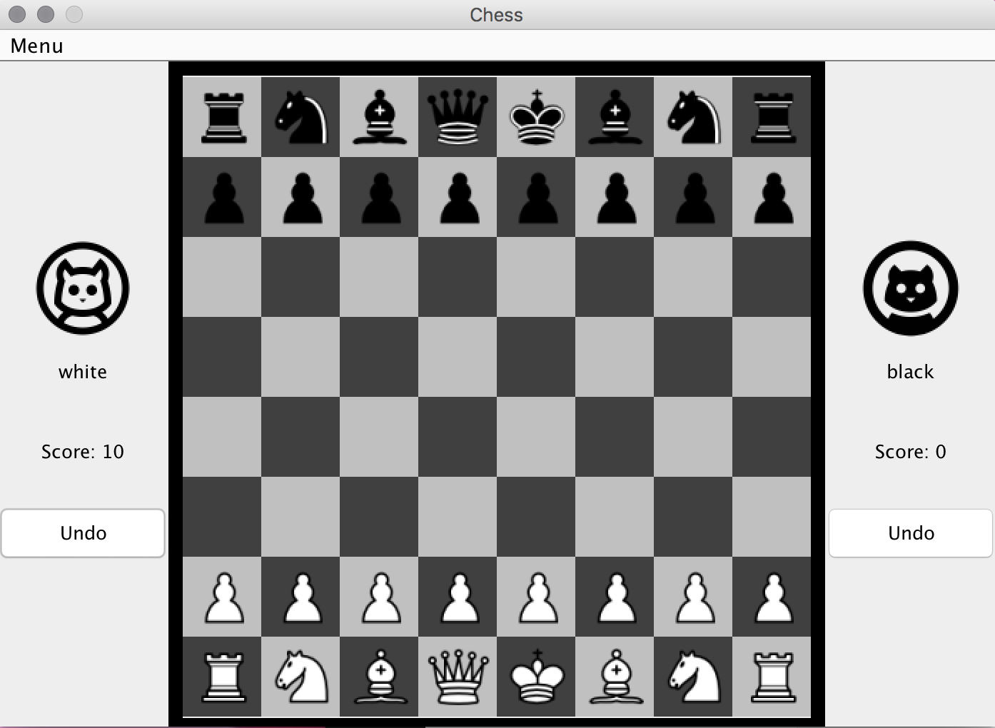

**To test “Forfeit” button:**

Let’s make a couple of moves:

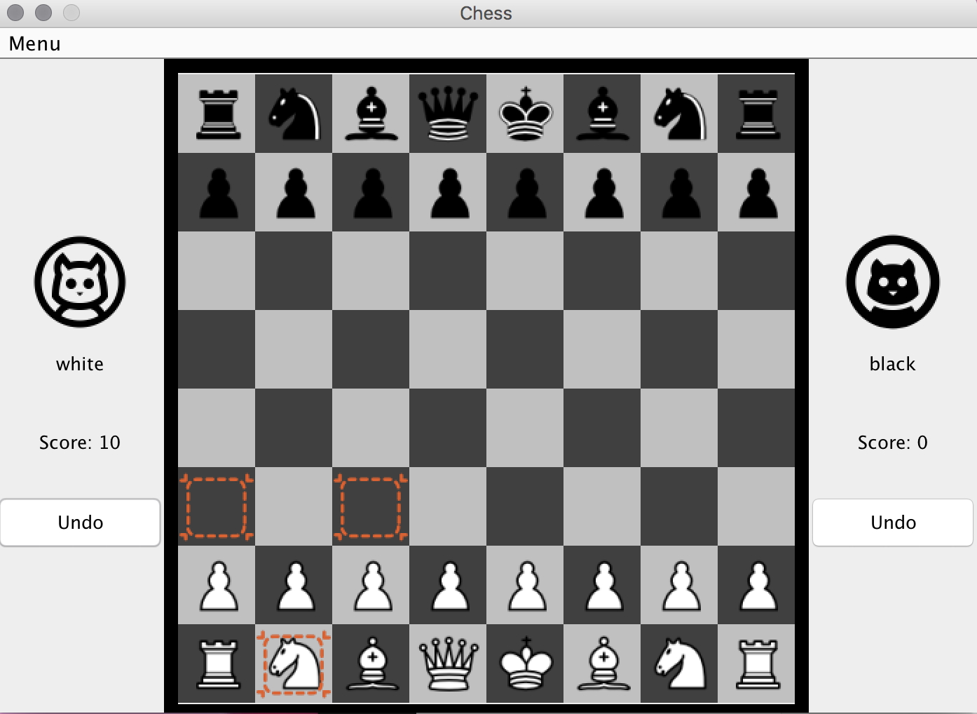

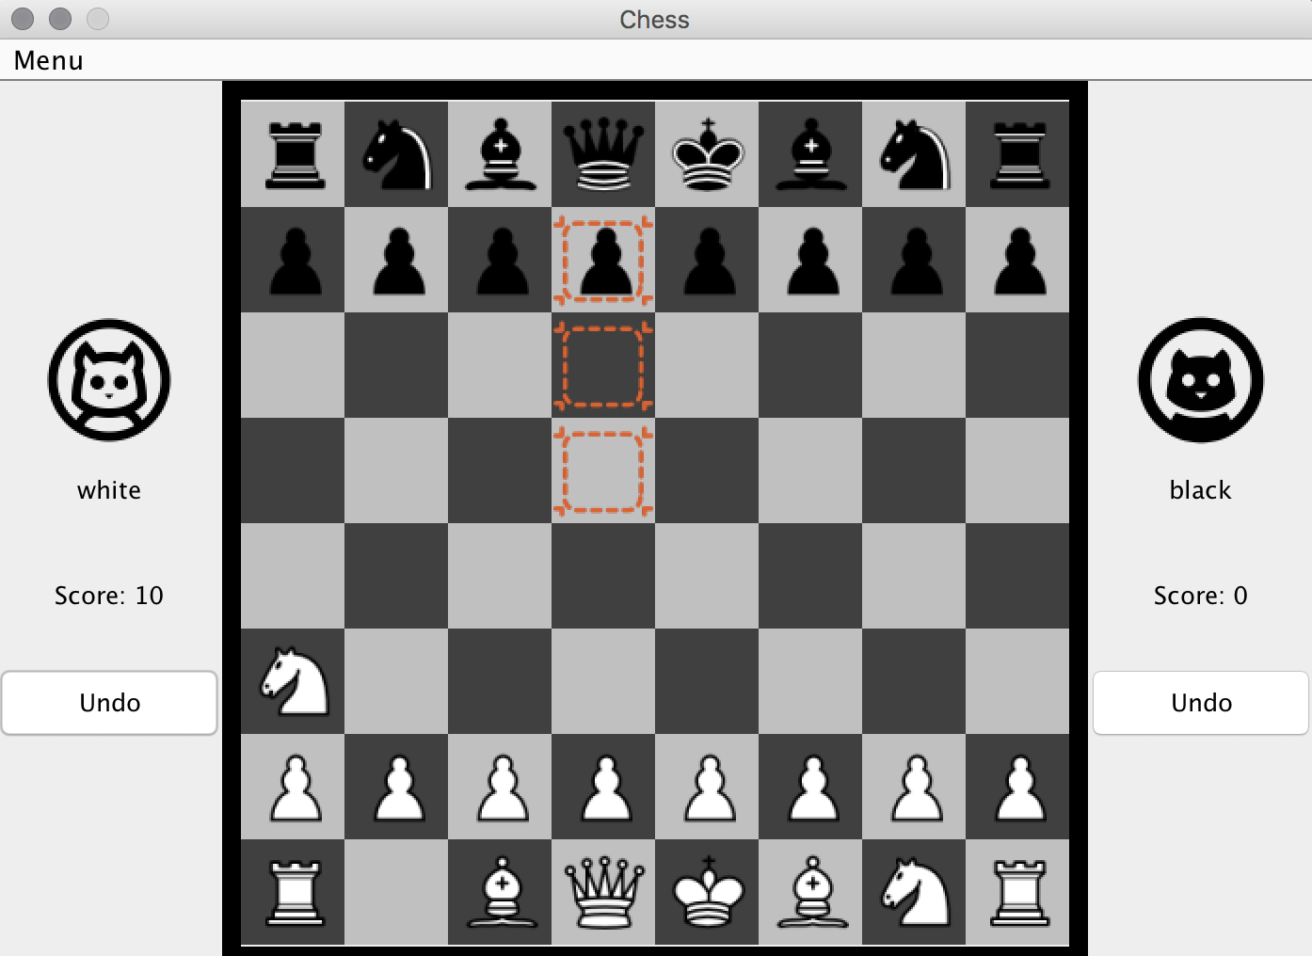

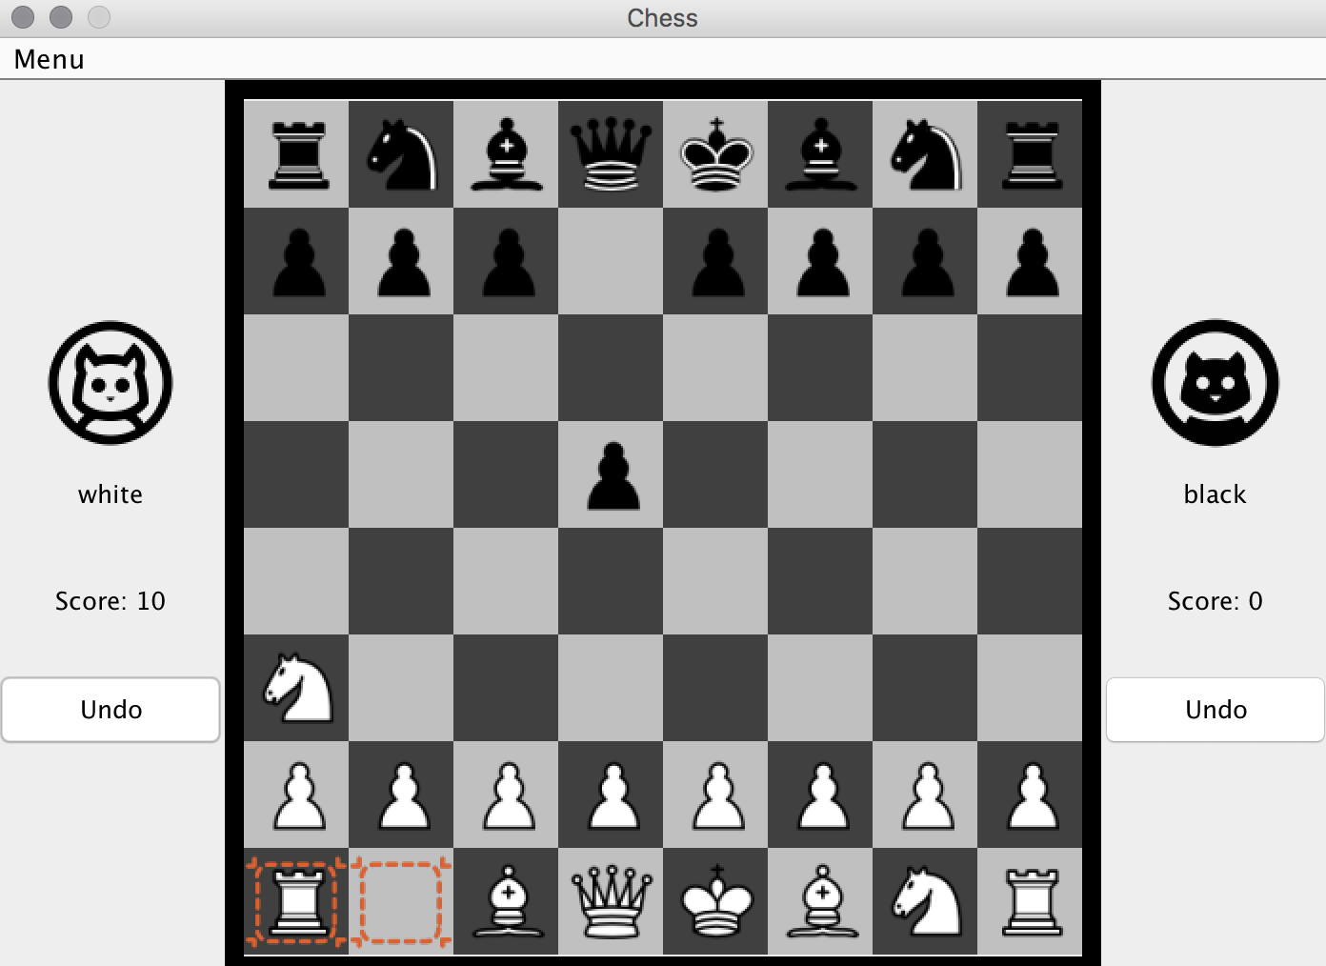

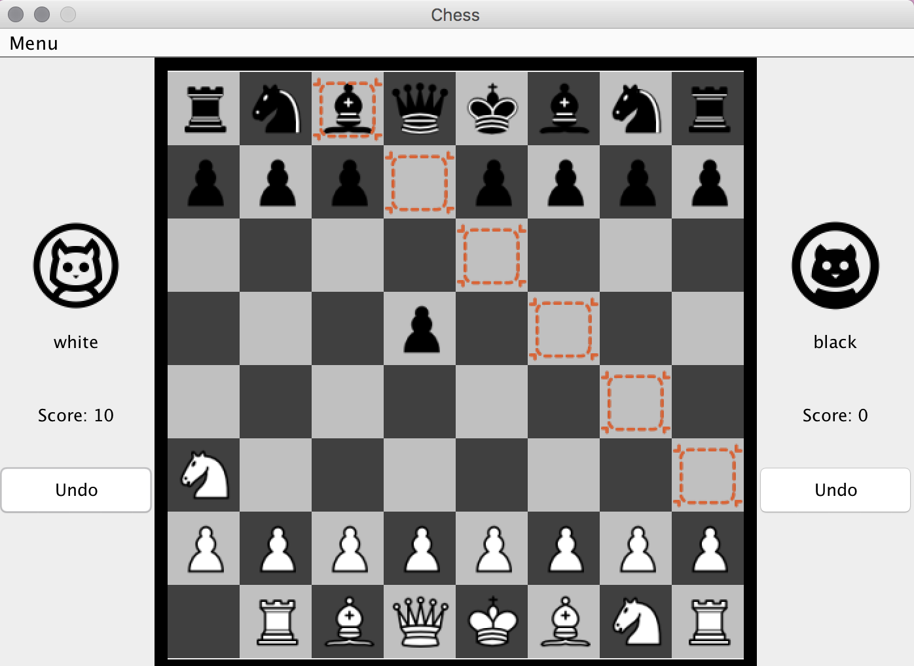

Now, suppose the black player doesn’t want make the move and decide to forfeit, click “Forfeit” in the menu:

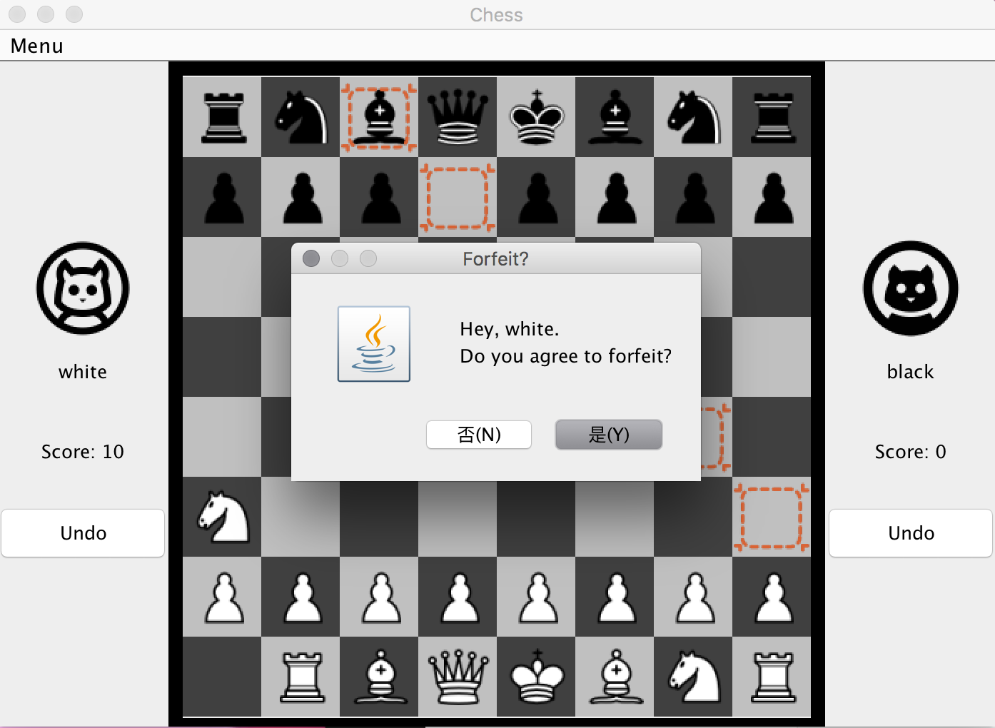

Since it is the black player’s turn, there will be a confirmation window to ask whether the other player (white player) agrees to forfeit.

Click on “No”, the game will be continued.

Click on “Yes”, the game will restart and it will asked whether to play with custom pieces:

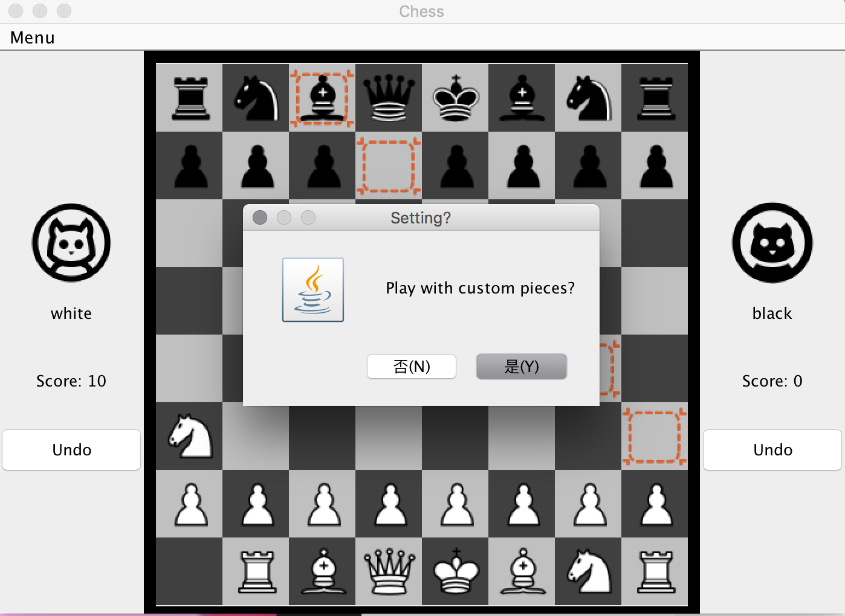

Click on “Yes”, custom board will be displayed, and score is still recorded:

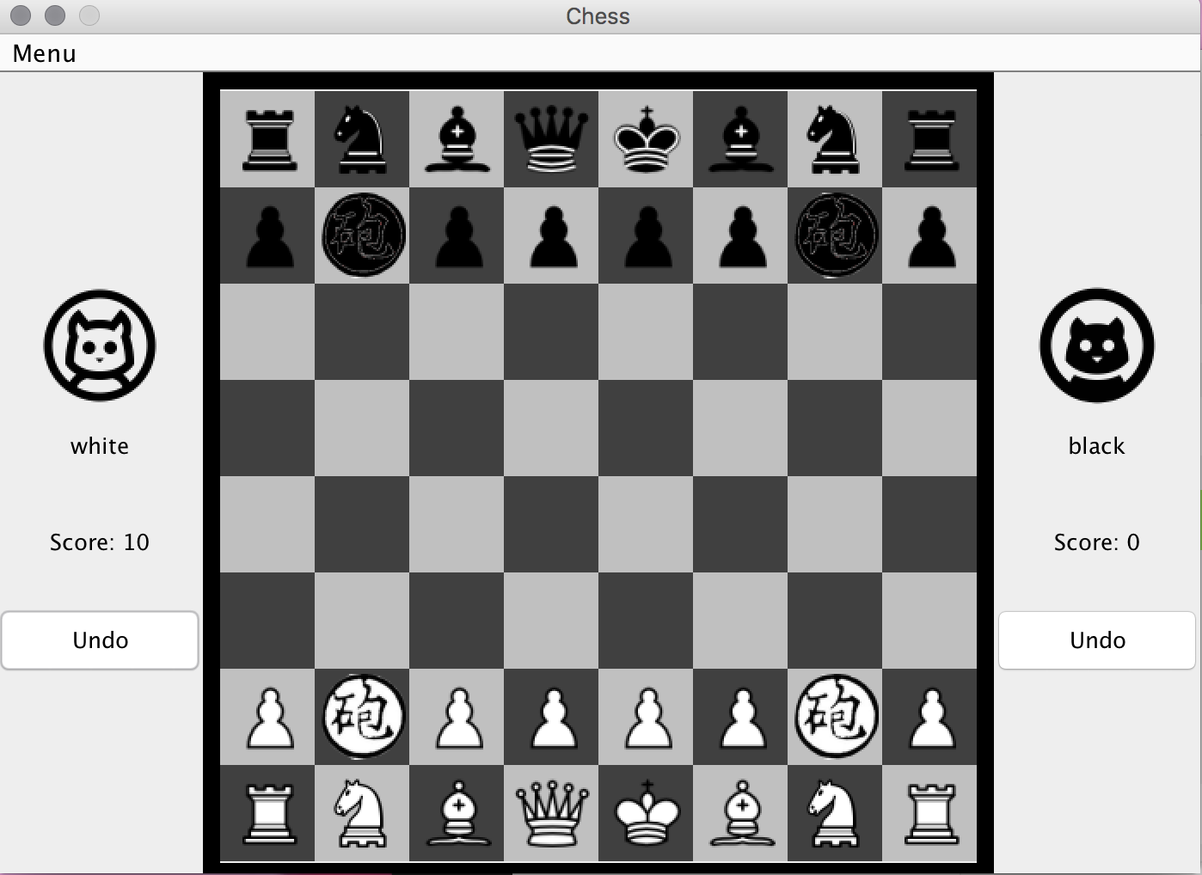

**To test custom pieces:**

Click on one of the hoppers:

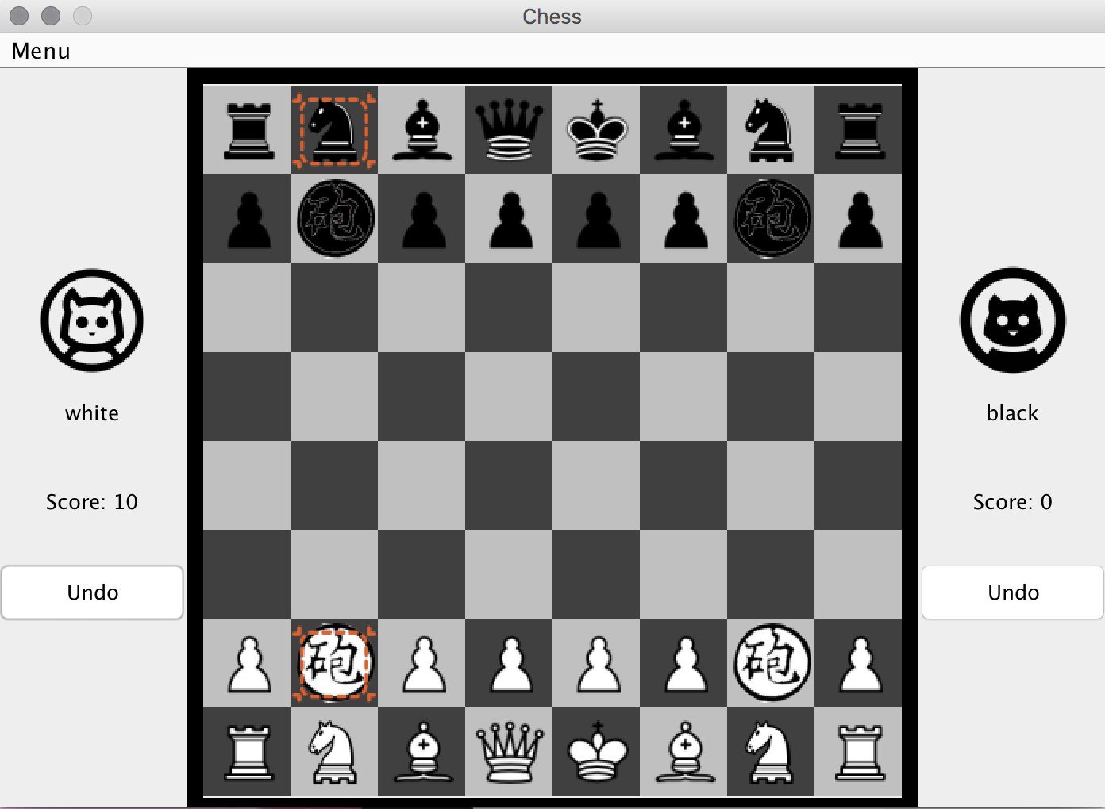

Click on the empress highlighted and capture it:

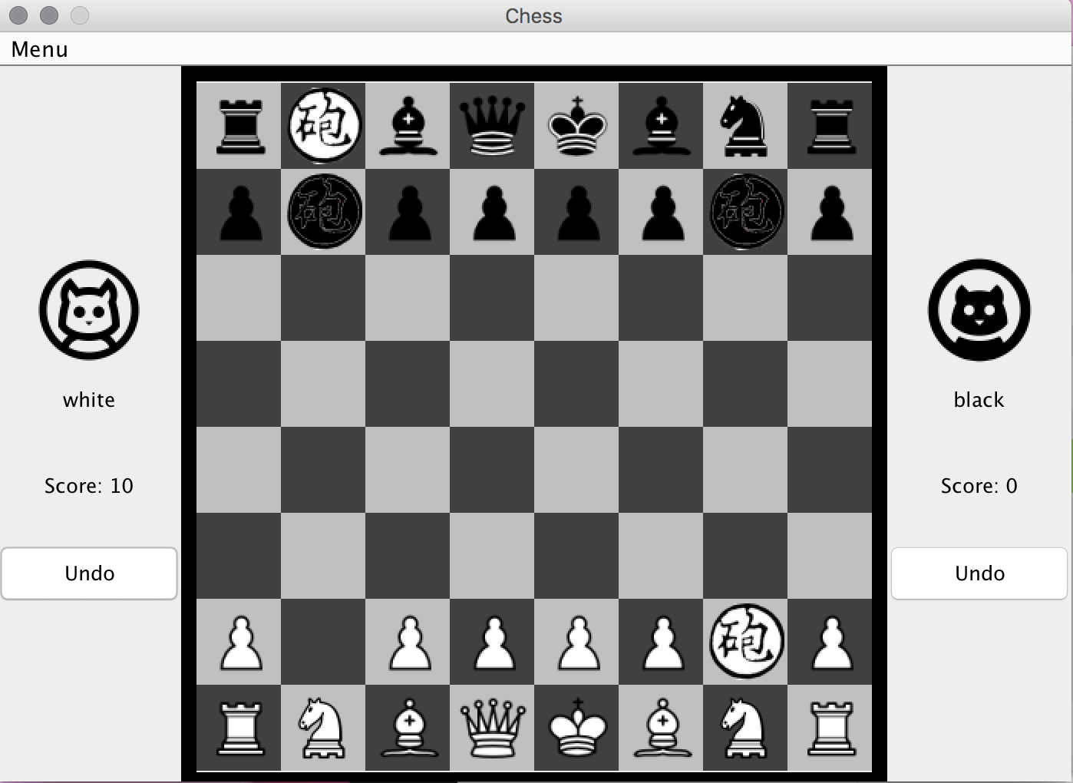

Click on the black hopper on the left and there should not be any legal moves:

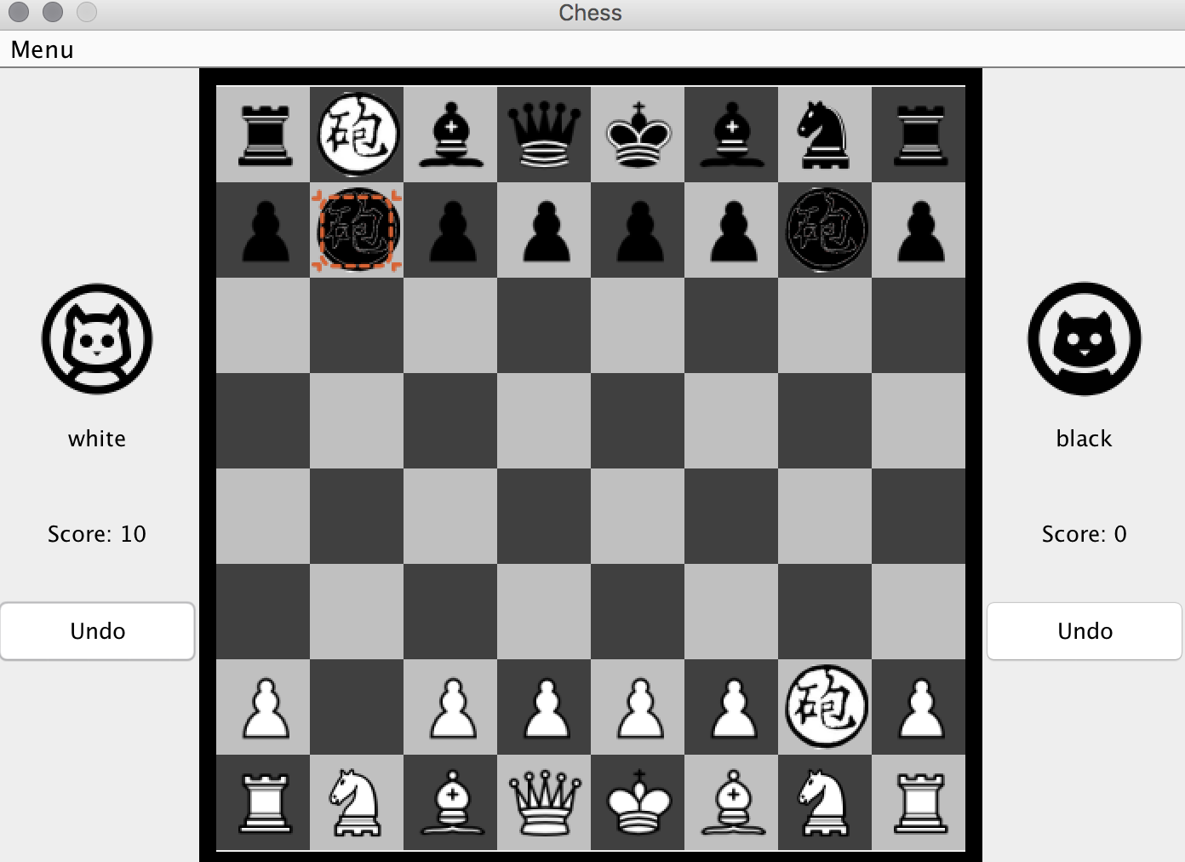

Click on the empress, it can move like a knight and rook:

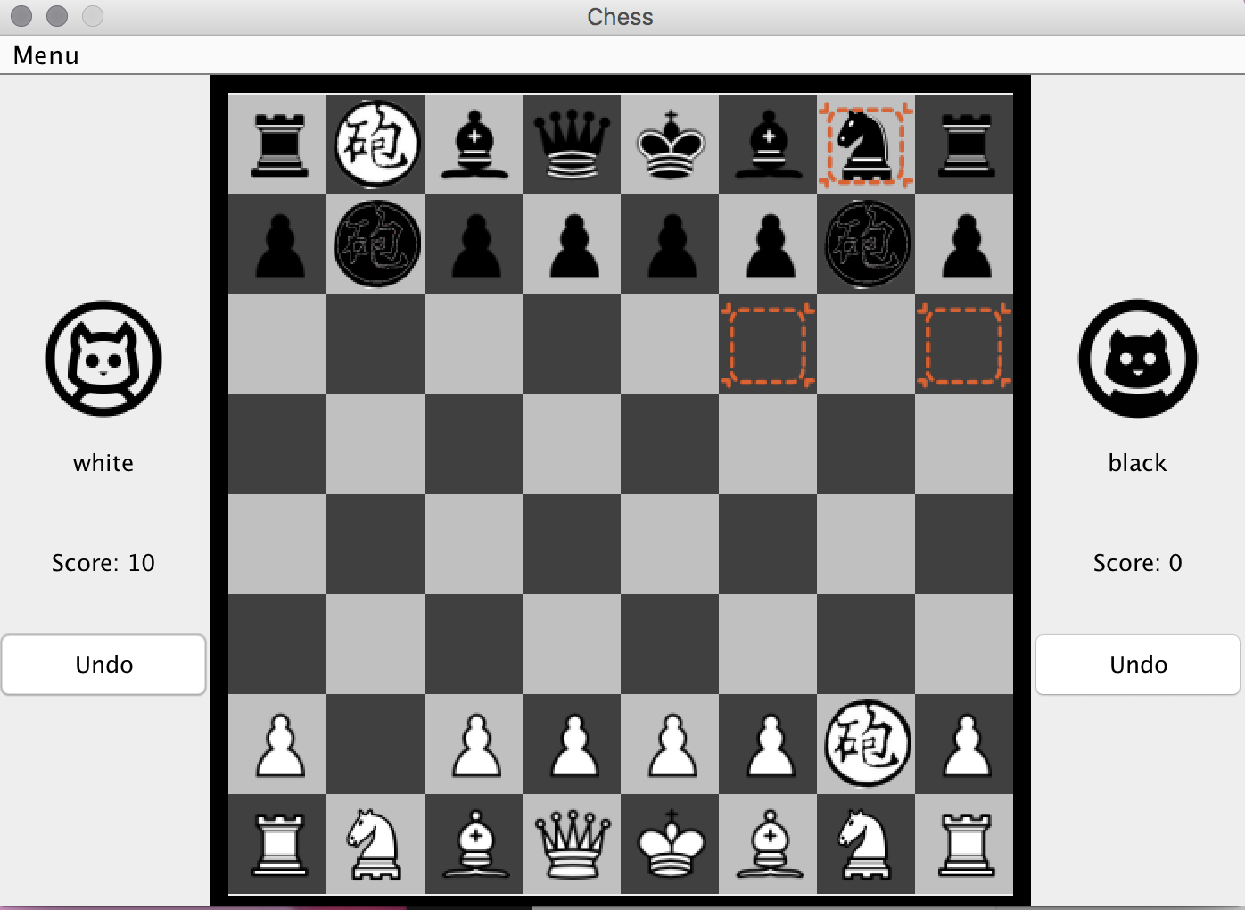

Click on one of the highlighted square to move the black empress.

Click on the white empress and the whole column should be highlighted since there is no piece blocking the empress to move like a rook:

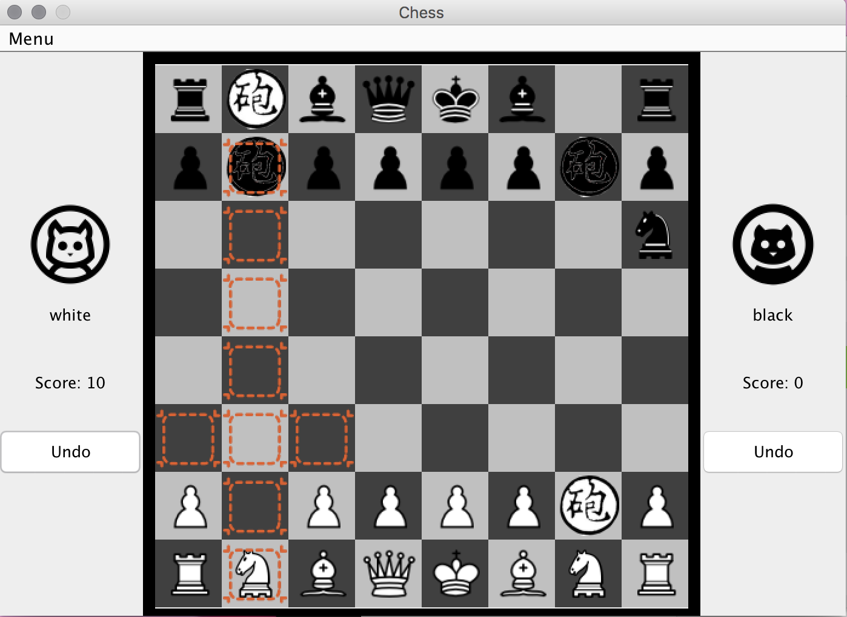

To test stalemate:

Start a new standard game with same players by click on “Restart” and “No” for the confirmation dialog.

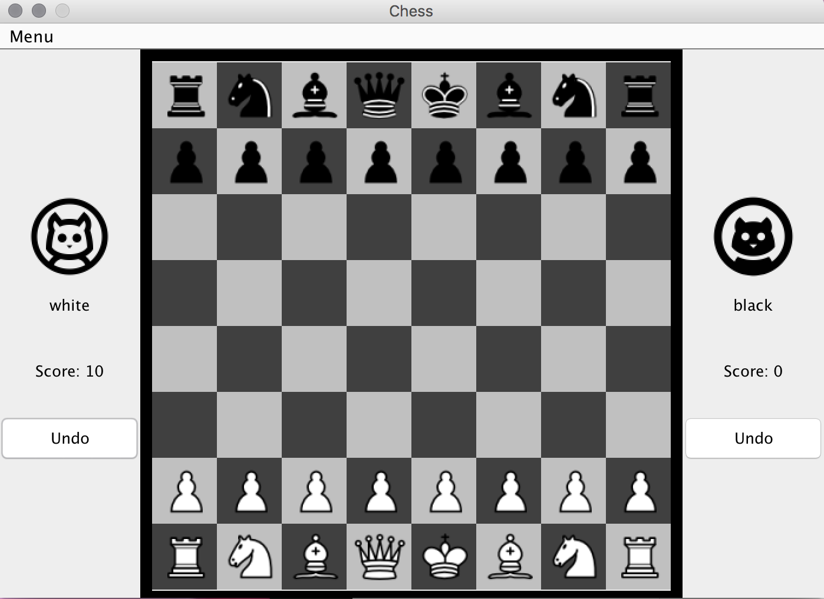

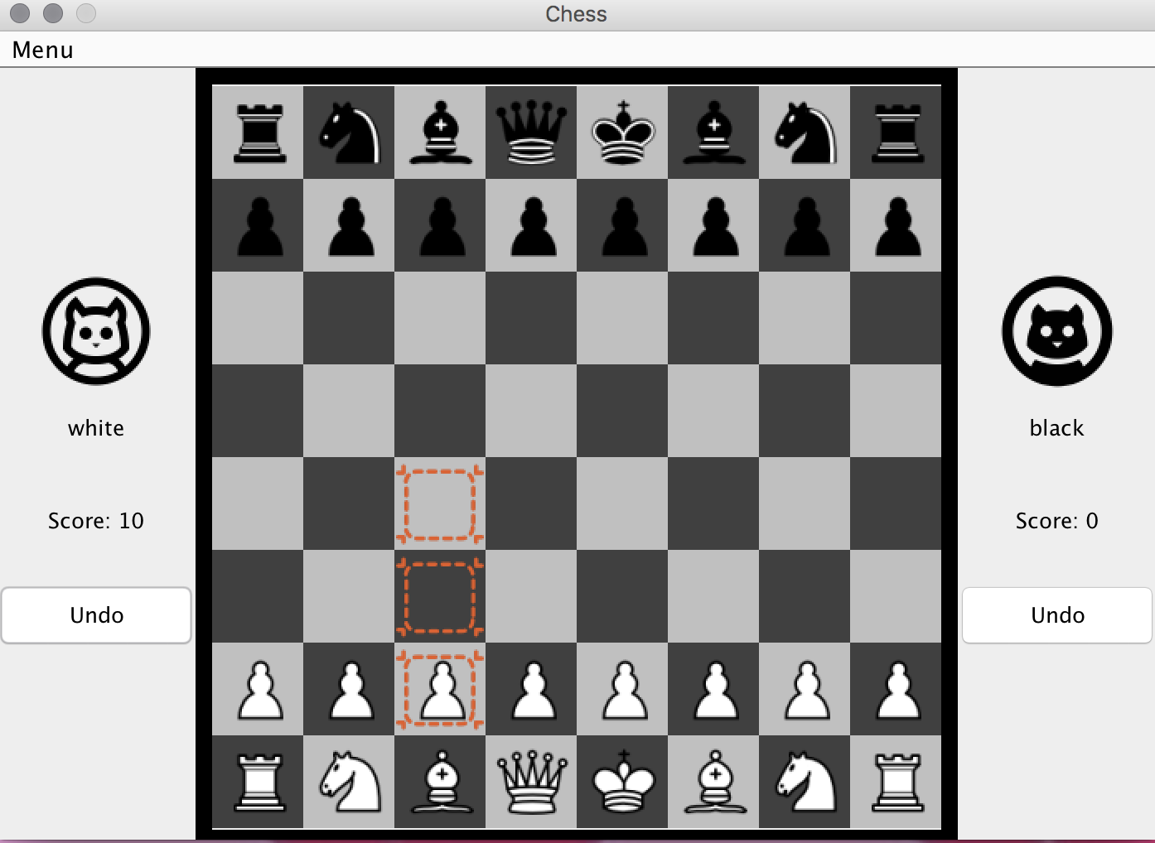

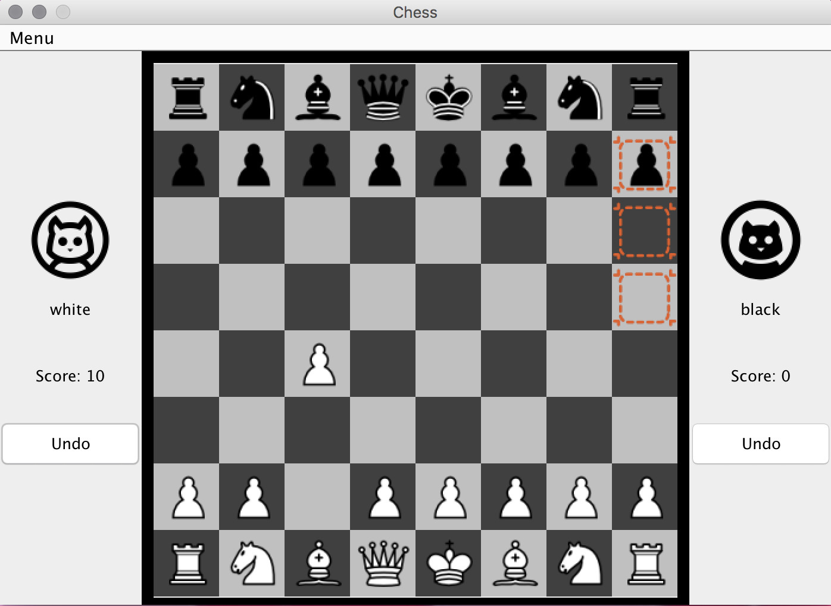

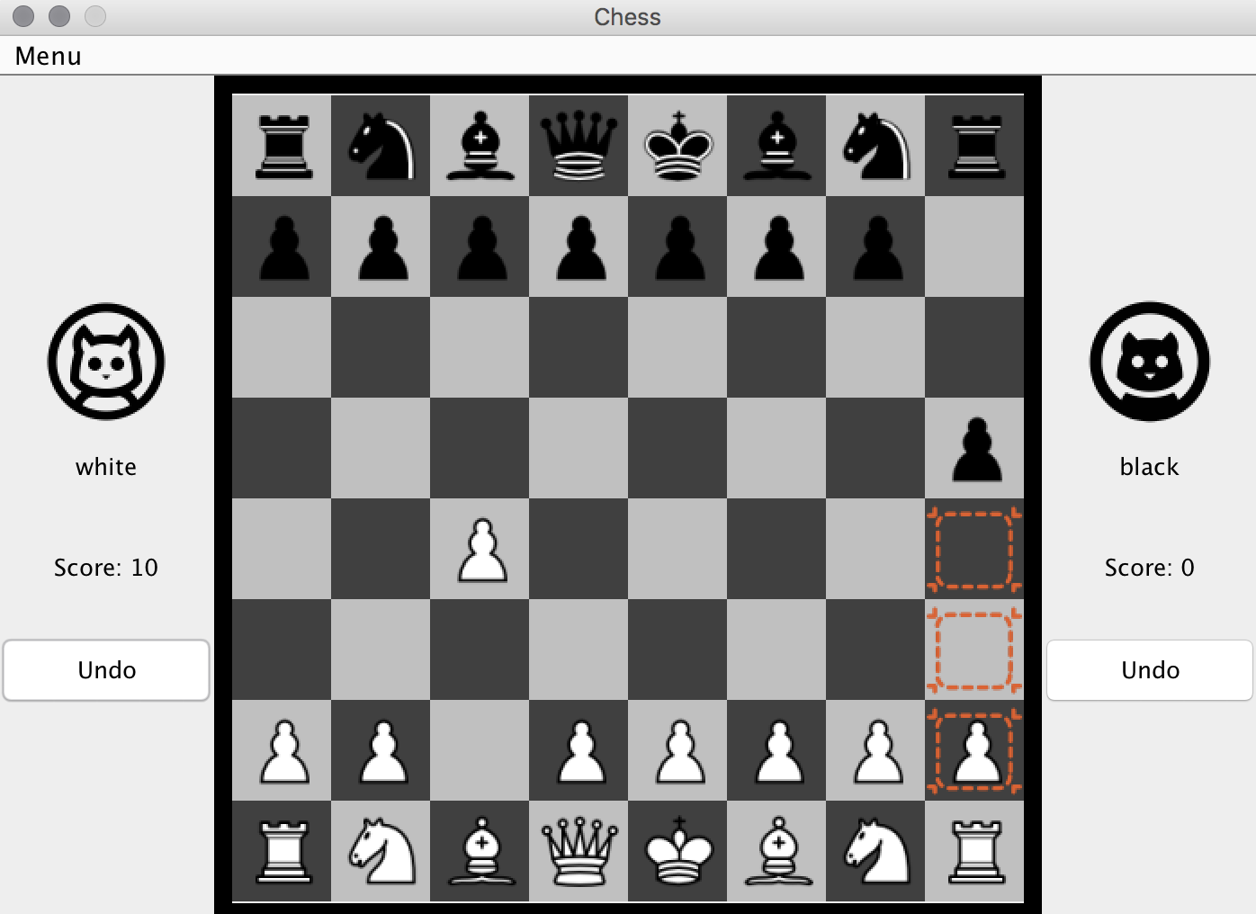

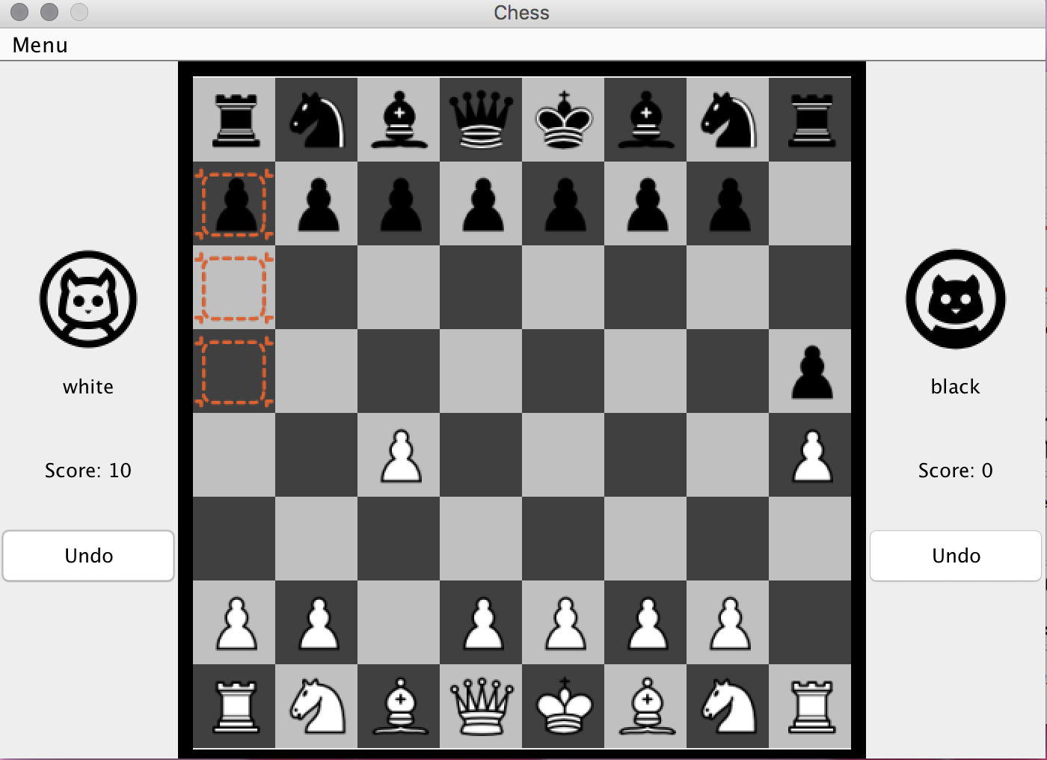

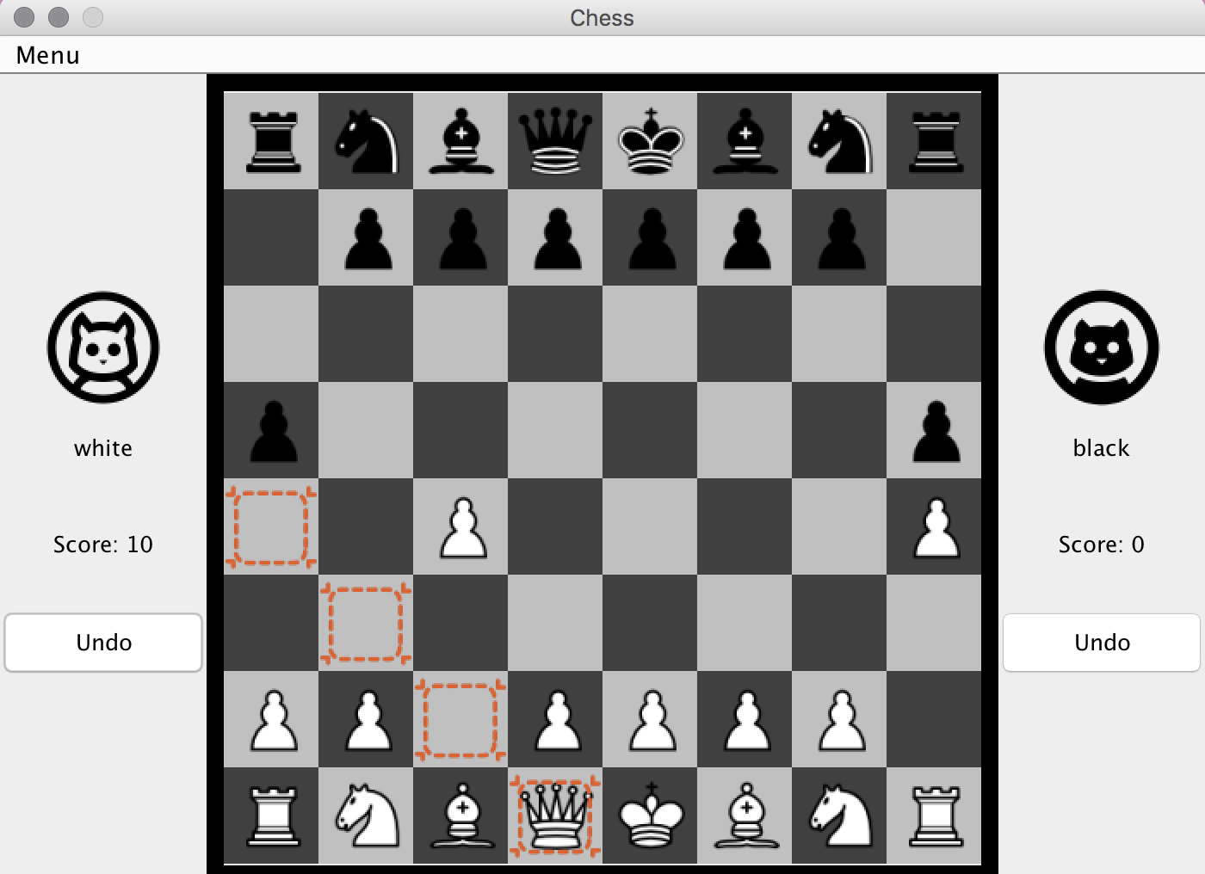

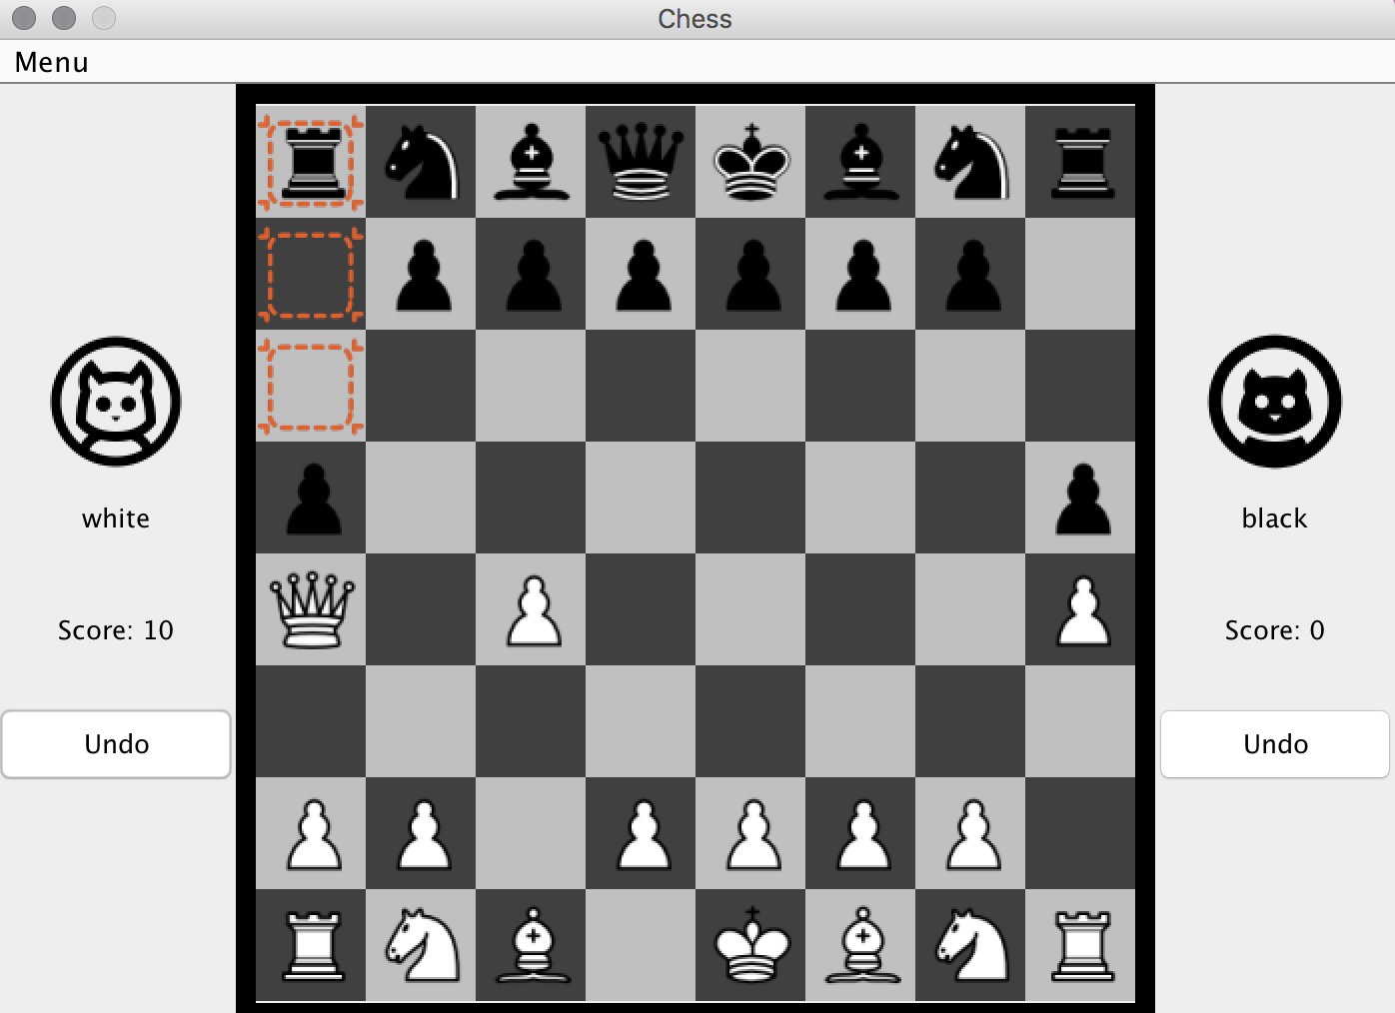

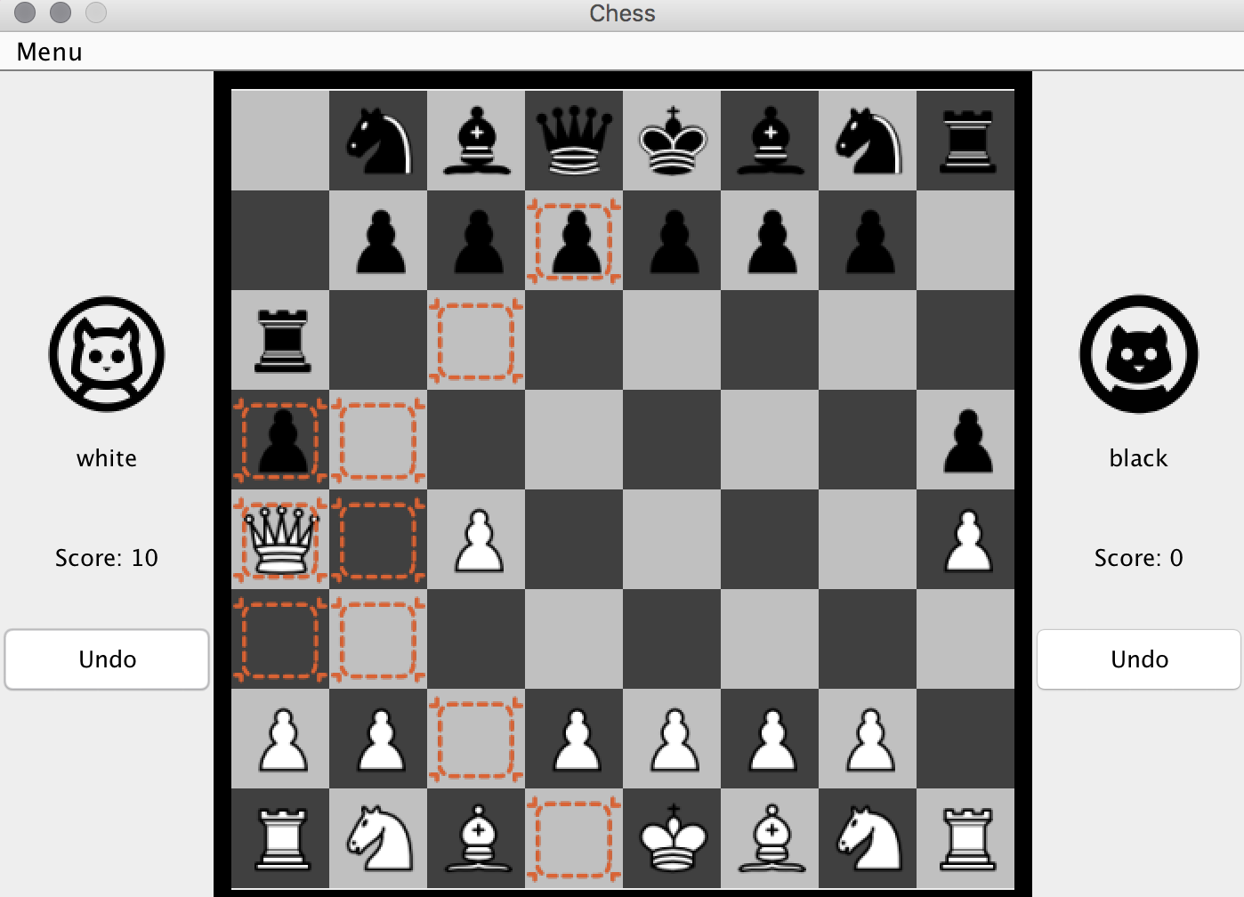

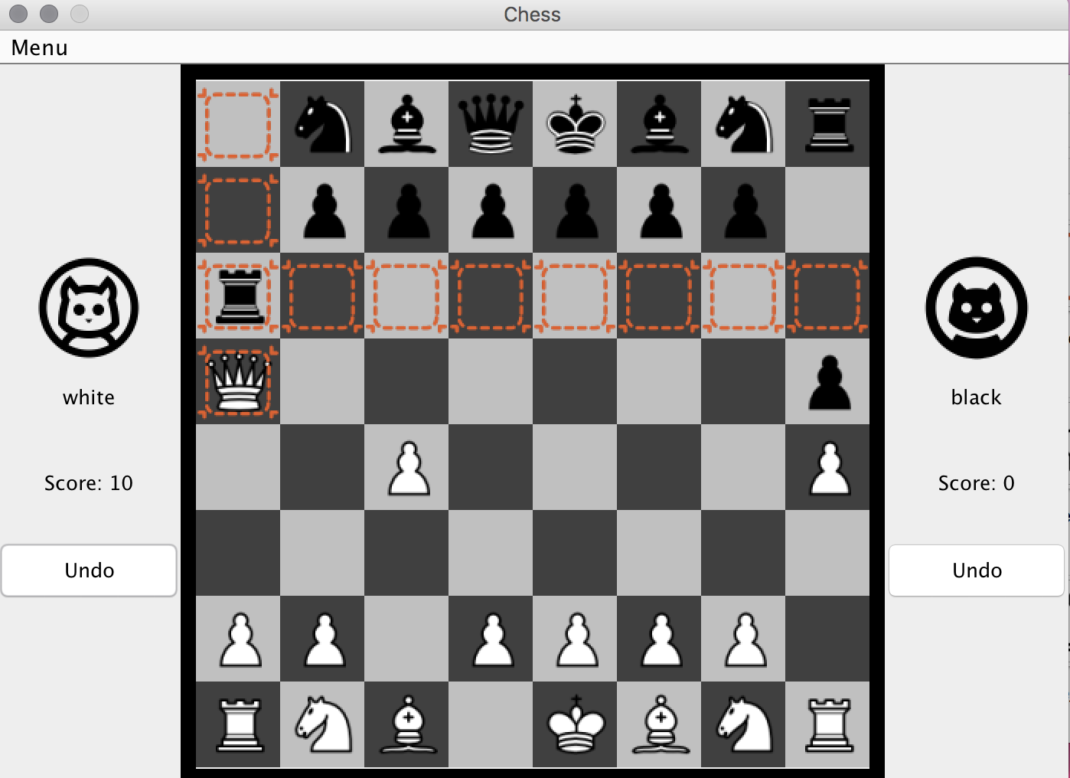

Stalemate